**UNIVERSITY OF CALOOCAN CITY**

***Congress Campus***

***COMPUTER STUDIES DEPARTMENT***

CSD E Learning System

In partial Fulfilment of the requirements for

Software Engineering

Members:

Boreres, Jespher M.

Ogardo, Gerald M.

Pacamara, Jhuriliane H.

Peteros, Alejo O.

BSIS-3A

Submitted to:

Prof. Jason Joble

S.Y: 2023-2024

**CHAPTER 1**

**INTRODUCTION**

The CSD E-learning management ensures that students in University of Caloocan City have access to high-quality education through technology by playing a major role in the deployment and management of e-learning systems. The goal of the CSD E-learning manage is to support education by offering a platform for communication, teamwork, assessment, and course delivery. These web-based systems contain a variety of data in databases, including student records, instructor resources, and course materials. The CSD E-learning management is responsible for the design, implementation, and maintenance of these e-learning systems. This involves developing software that meets the requirements of the department and the needs of the students of UCC.

* 1. **Background of the Study**

The CSD E-learning system utilizes technology and digital platforms to enhance teaching and learning within the Computer Studies Department (CSD). It employs a Learning System to deliver course content, monitor student progress, and facilitate communication between instructors and students. Integrating e-learning management in the Computer Studies Department improves access to education, provides flexibility and convenience for students, and enhances the overall learning experience.

**1.2 Statement Objectives**

1.2.1 General Objectives

1.2.2 Specific Objectives

The specific objectives of the study are the following:

**1. 3 Significance of the Study**

**1.4 Scope and Limitations of the Study**

Scope:

Limitations:

**CHAPTER 2**

**METHODOLOGY OF THE STUDY (SDLC)**

The Iterative waterfall model can be thought of as a version of the classic waterfall model that incorporates the requisite improvements to make it operational in real world system development projects.

**Planning**

**Analysis**

**Design**

**Coding**

**Implementation**

**Test & Integration Phase**

**Maintenance**

* **Planning Phase**

The developers planning to create a system that benefits the user. After that, the developers gather all the possible information that helps the system that they planned to developed.

* **Analysis Phase**

In the Analysis phase of the CSD E Learning System, developers check if the system they're building can actually work. They look closely at what's needed and what might cause problems.

* **Design Phase**

In the Design Phase, developers figure out what the system needs to do. They work out the details to make sure everything is clear before they start building it.

* **Coding Phase**

In this phase the developers start to encode all the requirement of a system and the gathered information that needed in the developing system by following the plan and design.

* **Implementation Phase**

During the Implementation Phase of the CSD E Learning System, developers and researchers utilize it to put the system into action. Every part of the system tested by the developers to check its functionalities.

* **Testing & Integration Phase**

During the Testing & Integration Phase of the CSD E Learning System, developers create and build the system along with its functions. They do this to test and manage any problems that might have cropped up during the design phase.

* **Maintenance Phase**

In the final phase of the CSD E Learning System, developers assess the system to see if any parts need improvement, enhancement, or change based on feedback they've received.

**CHAPTER 3**

**DATA GATHERING**

**3.1 Data Gathering Procedures**

The researcher prepared a referral letter seeking approval. After seeking for the approval, the researchers prepared the questions to be asked, had them checked and approved by the professor and then conducted a client interview. An interview will be conducted to support the researcher study. The interview would be most likely through calls or online communication.

**3.2 Data Gathering Instrument**

This study utilized interviews as its primary instrument for data collection. Additionally, questionnaires were employed to supplement the interview findings.

**Interview**,

The researchers made use of this instrument because there are only specific persons in the existing system.

**Questionnaire**,

The researchers used open ended questions to elaborate the complex ideas involved in the system and closed ended questions to know the specific answers.

**CHAPTER 4**

**THE EXISTING SYSTEM**

**4.1 Company Background**

A. The Company Name

* Company Name

Claroline Solutions Inc.

B. Name of Business

* Product Services

Claroline - E-Learning Solutions

C. Brief History of the Company

Claroline Solutions Inc. was founded in 2001 by a group of educators and technologists passionate about revolutionizing the field of education through innovative digital solutions. Originally conceived as an open-source project, Claroline aimed to provide a platform for educators to create online learning environments that foster collaboration, engagement, and personalized learning experiences for students worldwide. Over the years, Claroline has grown to become a leading provider of E-learning solutions, serving educational institutions, corporations, and training organizations globally.

**4.2 Description of the System**

Claroline is an advanced Learning Management System (LMS) designed to empower educators and learners with a robust set of tools for online teaching and learning. The system allows educators to create and manage courses, upload learning materials, facilitate discussions, and assess student progress. Students can easily enroll in courses, access resources, participate in activities, and track their learning journey.

Key features of the Claroline system include:

* User-friendly interface for both educators and learners
* Course creation and management tools
* Content sharing capabilities, including multimedia support
* Discussion forums and chat functionalities for interactive learning
* Assessment and grading tools for evaluating student performance
* Customizable settings to accommodate various teaching styles and preferences
* Accessibility features to ensure inclusivity for all learners

**4.3 Data flow Diagram**

**Enrollment & Authentication**

**User Registration & |**

**| Authentication**

**Main Page**

**Course Management**

**Content Delivery**

**Feedback & Notifications**

**Assessment & Grading**

**Assignment Submission**

**4.4 Data Dictionary**

**User**

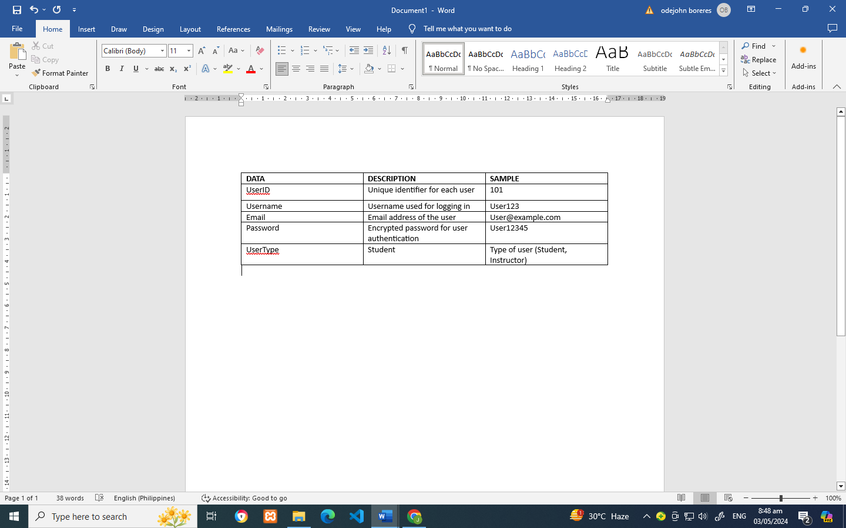

**Course**

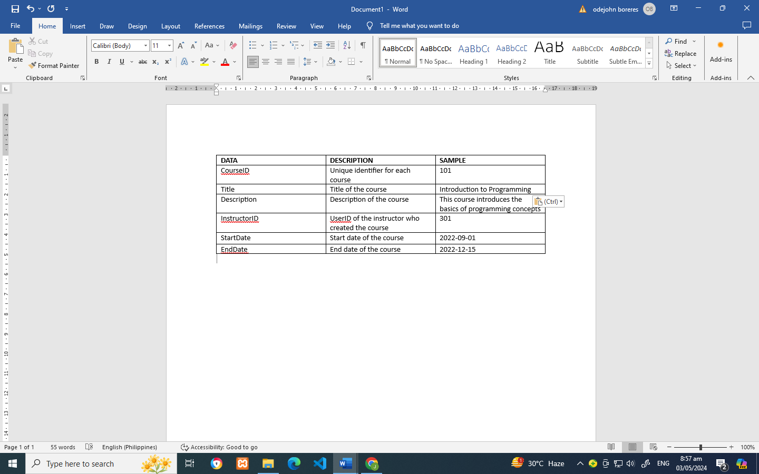

**Enrolment**

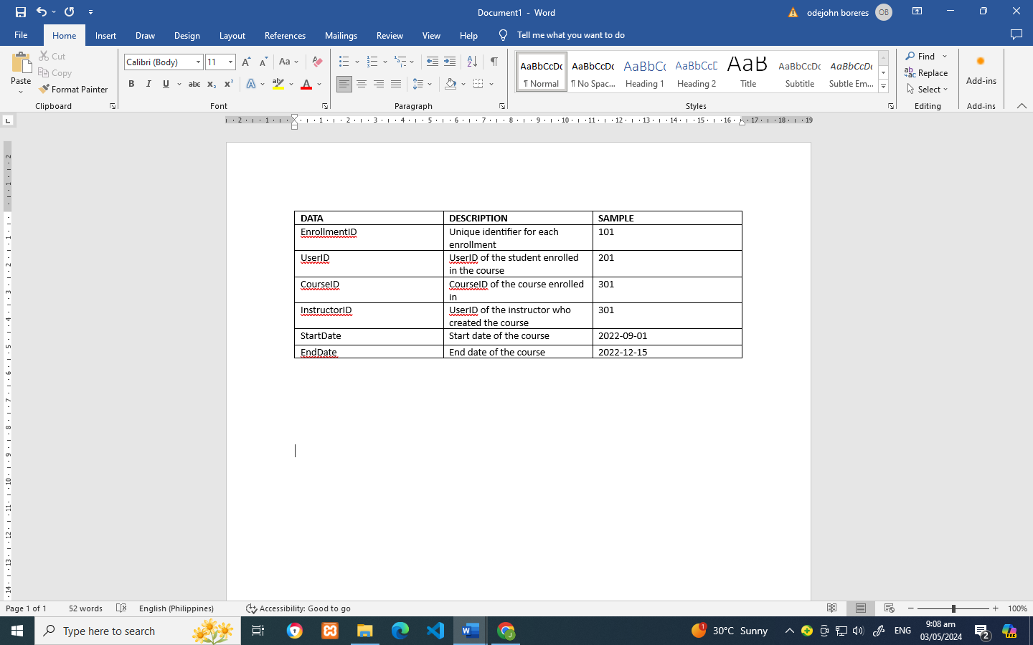

**Content**

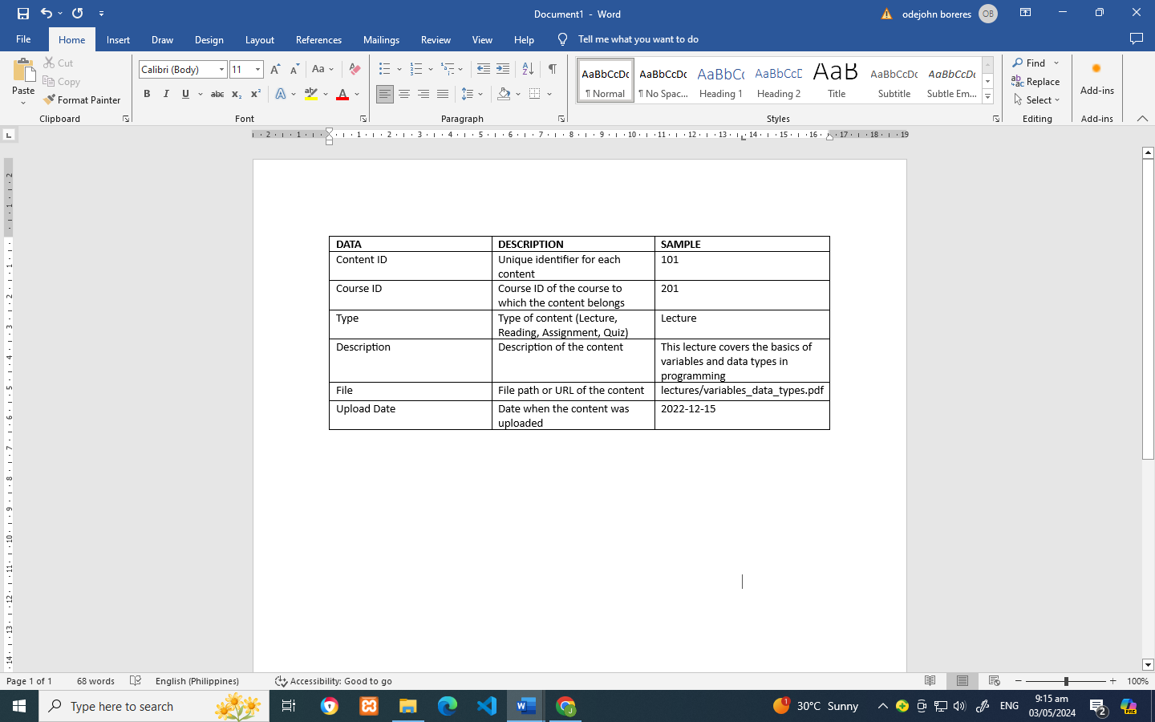

**Assignment**

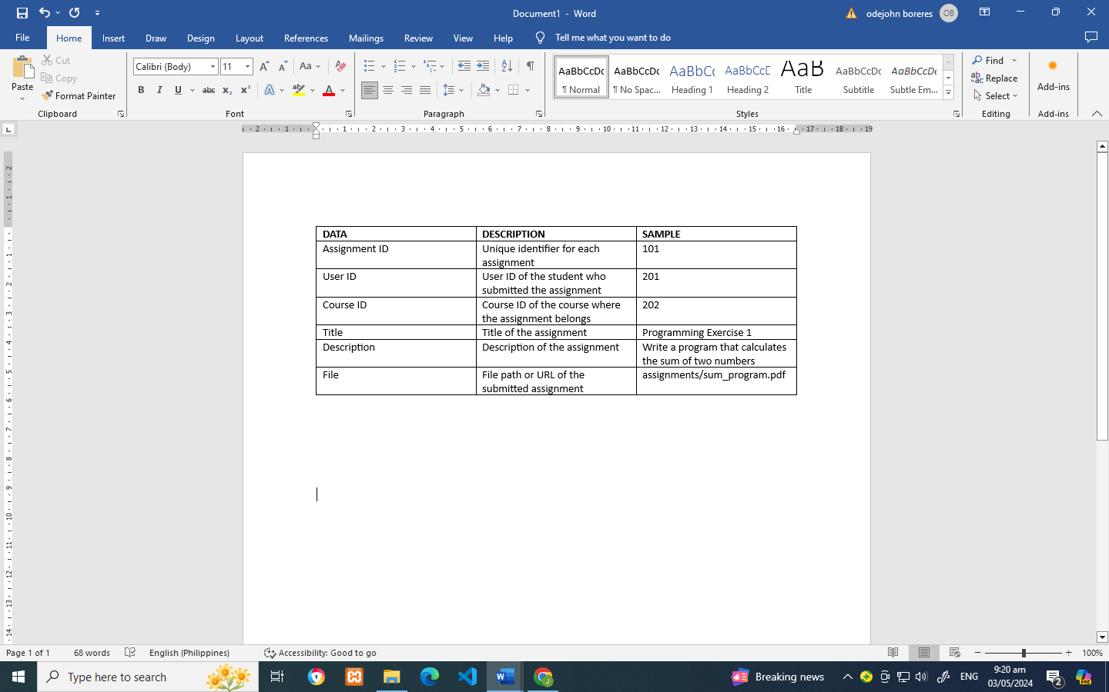

**Grade**

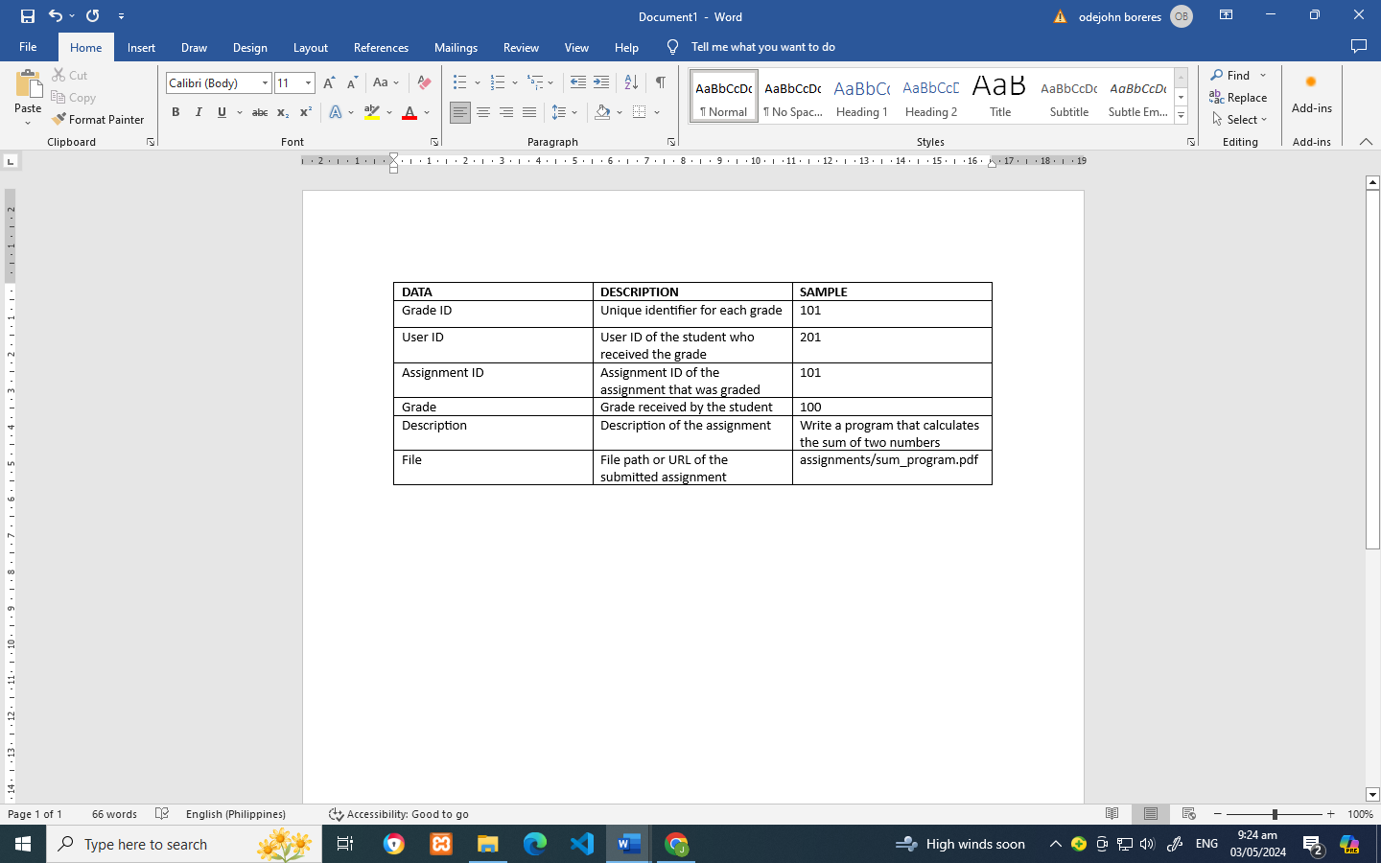

**Feedback**

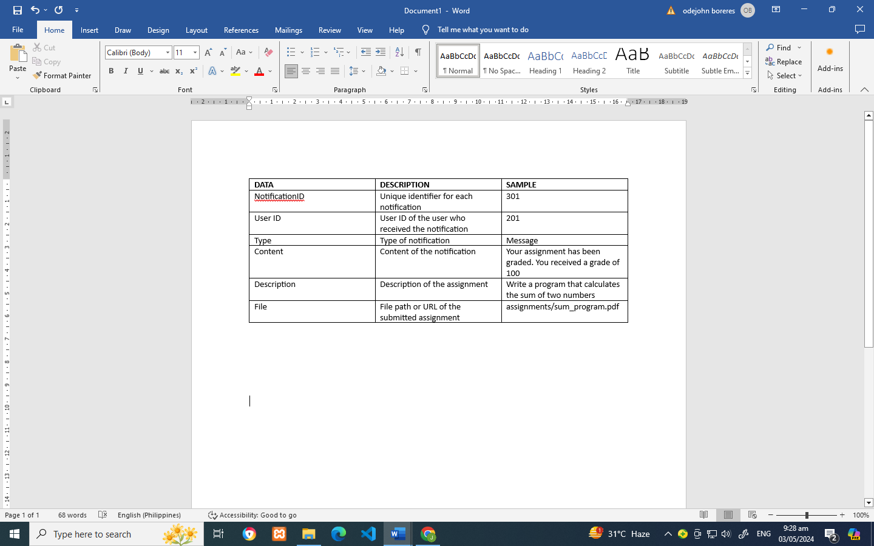

**4.5 Problem Areas**

**CHAPTER 5**

**THE PROPOSAL SYSTEM**

**5.1 System Overview**

The CSD E-Learning System we present our vision for a groundbreaking e-learning platform set to revolutionize conventional education through digital innovation. Our system is designed to seamlessly integrate technology into the learning process, offering students an intuitive interface to access a diverse range of resources including assignment, activities and messaging tools. Teachers will benefit from user-friendly features enabling them to create interactive lessons and assignments, thereby fostering a more dynamic and engaging teaching environment. This system emphasizes user-friendly features and customizable functionalities, ensuring an adaptable platform that can seamlessly integrate with existing educational frameworks. This flexibility allows educators to tailor the learning experience to meet the unique needs of their students while promoting collaboration and engagement.

Additionally, administrators will have efficient tools to manage accounts, facilitating smooth enrollment processes and administrative tasks. With our platform, we aspire to make learning accessible and enjoyable for all, catering to the diverse needs of modern learners and educators alike.

**5.2 Process Specification**

**5.2.1 Data Flow Diagram**

* **System Flowchart (Login Flowchart)**

**Start**

**Yes**

**No**

New User

Register

Log In

User create account

Username & Password

**Yes**

**No**

Account already exists

User exists?

**Yes**

User Main Page

Log In Succesfull

* **Student Functionalities**

**Main Page**

**Signup**

**Register**

**Login**

**Student Dashboard**

**Student Subjects**

**Total subjects**

**Activities**

**Lecture**

* **Instructor Functionalities**

**Login**

**Main Page**

**View**

**Students Enrolled**

**Instructor Dashboard**

**Create Subject**

**Add Subjects**

**Create Assignment**

* **Submit Assignment Functionalities**

Unmarked assignment

**View Assignment**

**Submit Assignment**

**Student**

**Marked**

marked assignment

Student records

Marks and comments

Unmarked assignment

Marks and comments

**Instructor**

Receipt

**Record marks and comment**

Data

**Returned marked assignment**

**Retrieve marked assignment**

marked assignment

**5.2.2 Data Dictionary**

Student Table

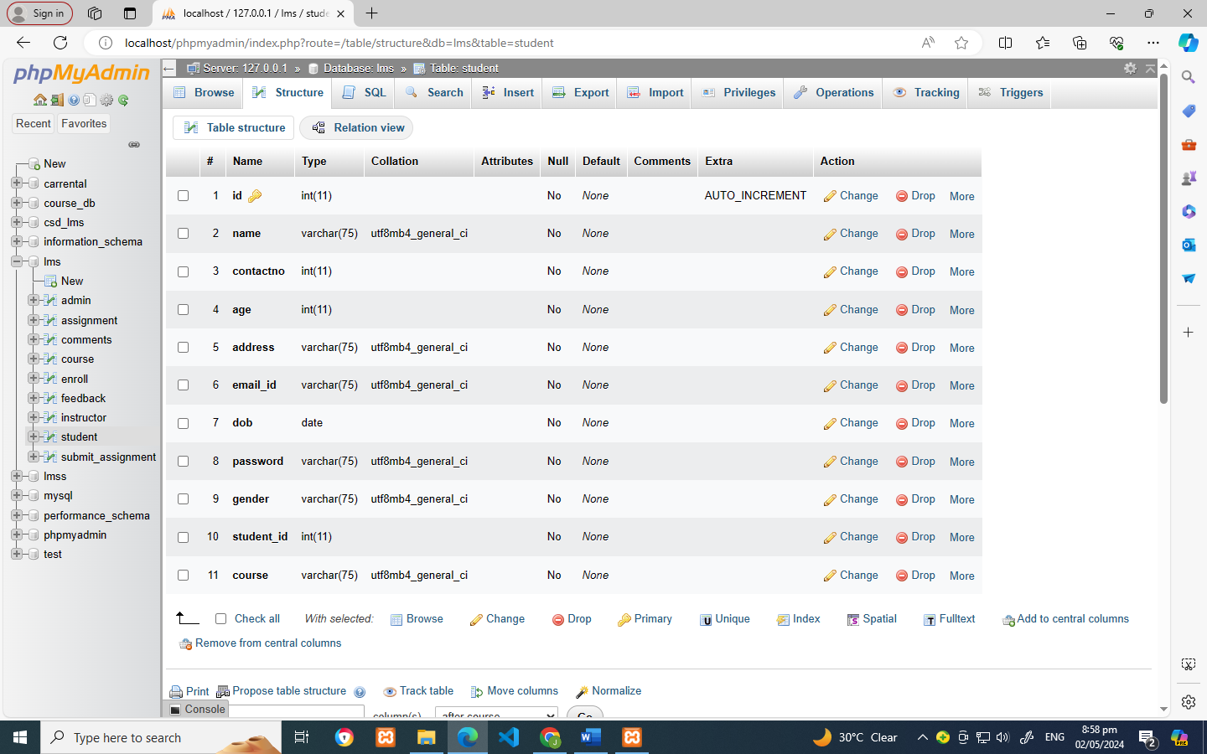

Instructors Table

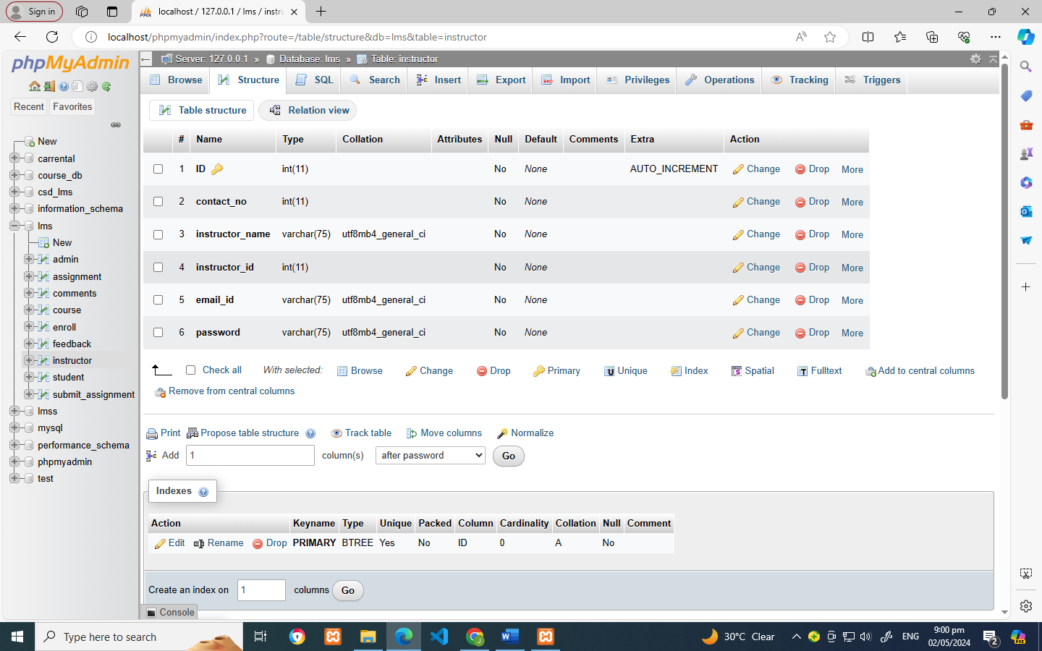

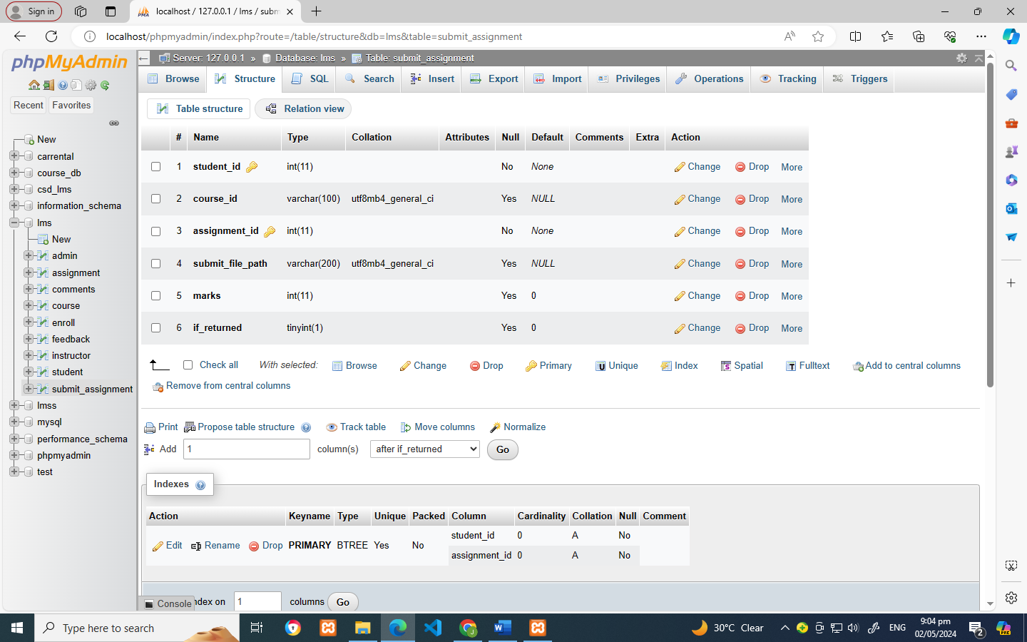Table Subject Submit assignment table

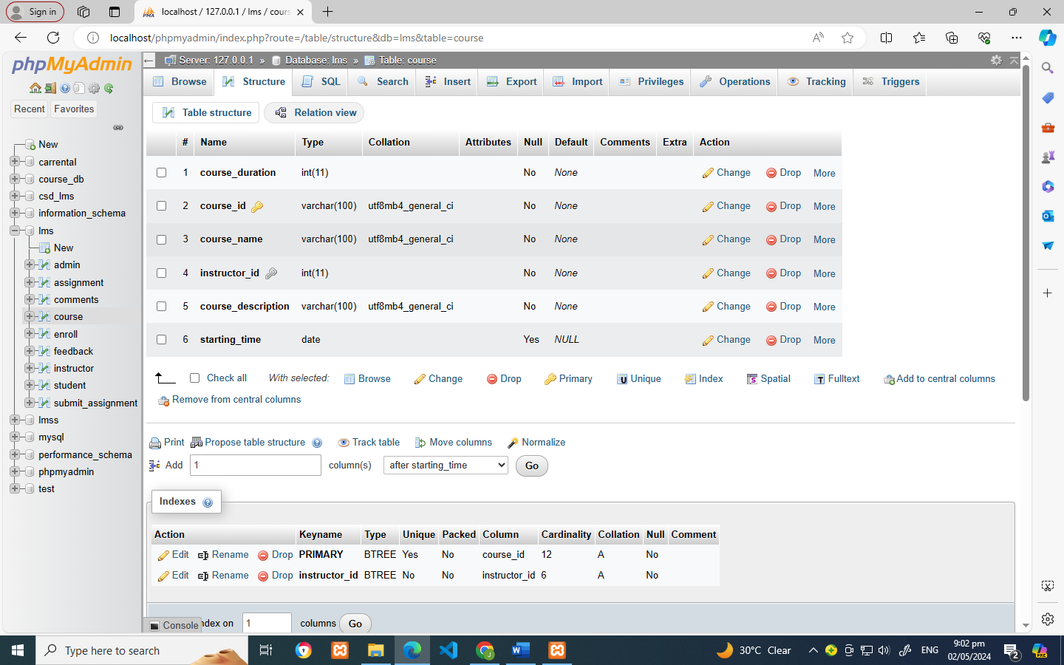

Assignment Table Enroll Subject table

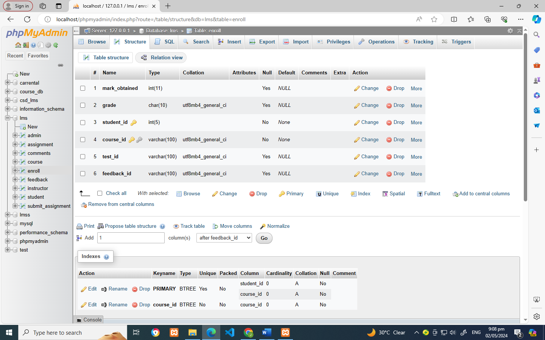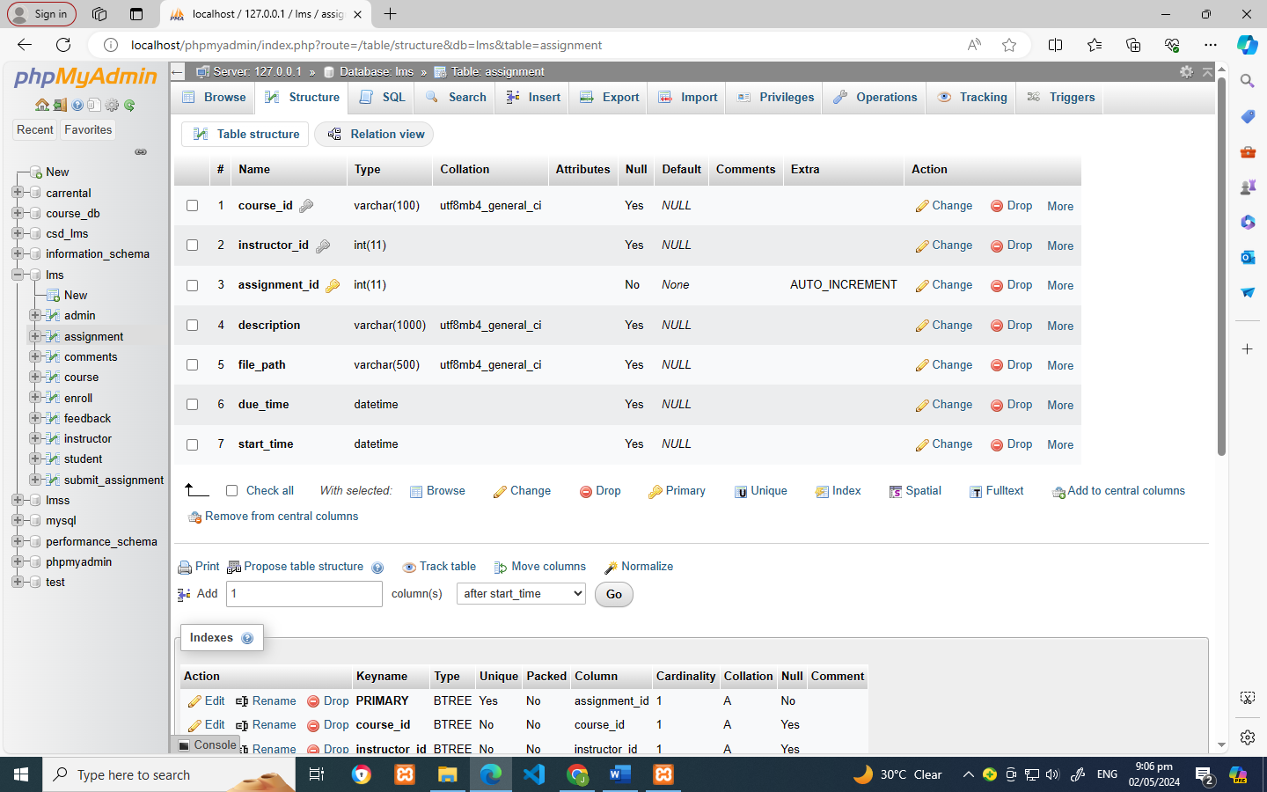

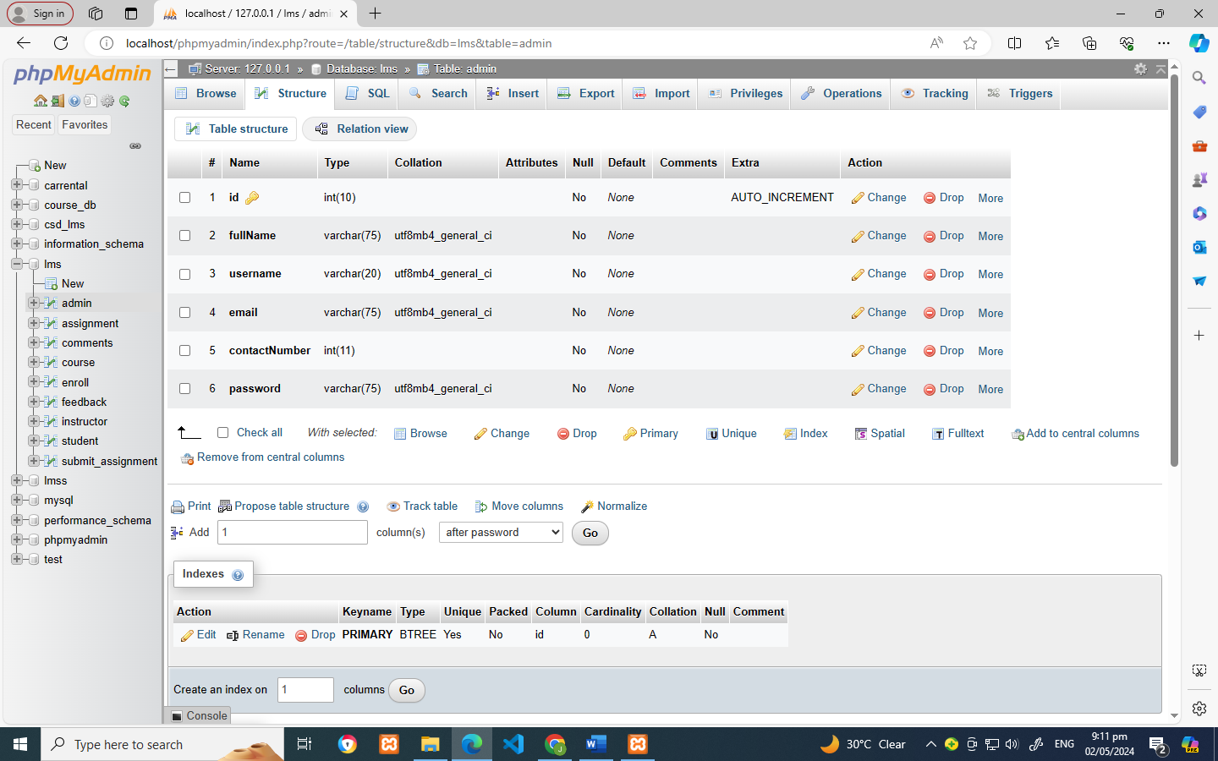Comments Table Admin Table

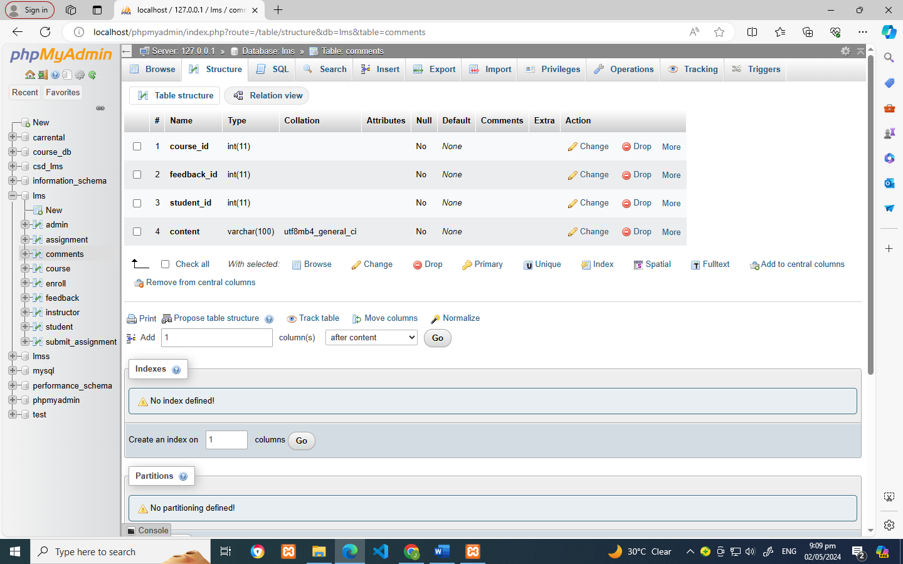

**5.3 Data Specification**

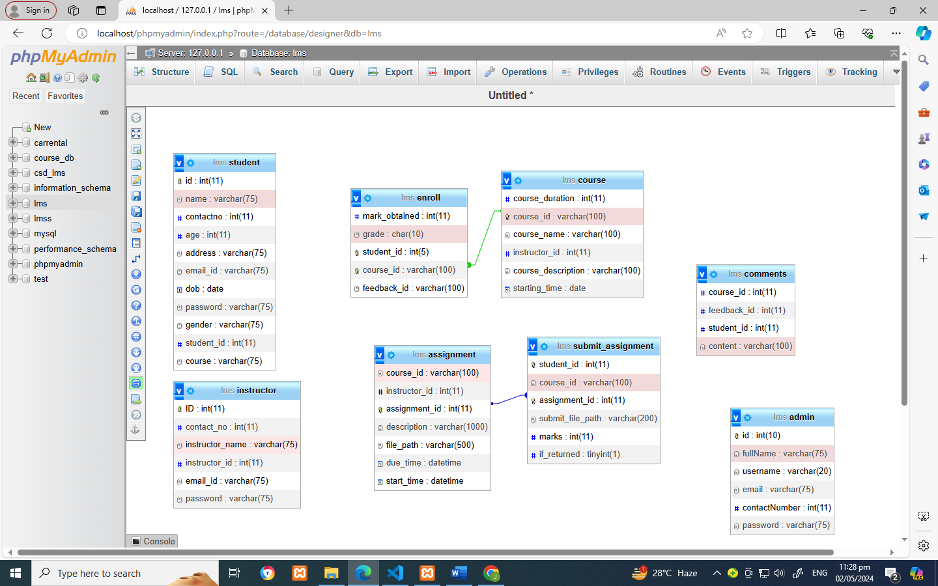 **5.3.1 Entity Relationship Diagram**

**5.3.2 Tables/ Flies Layout**

Student Table

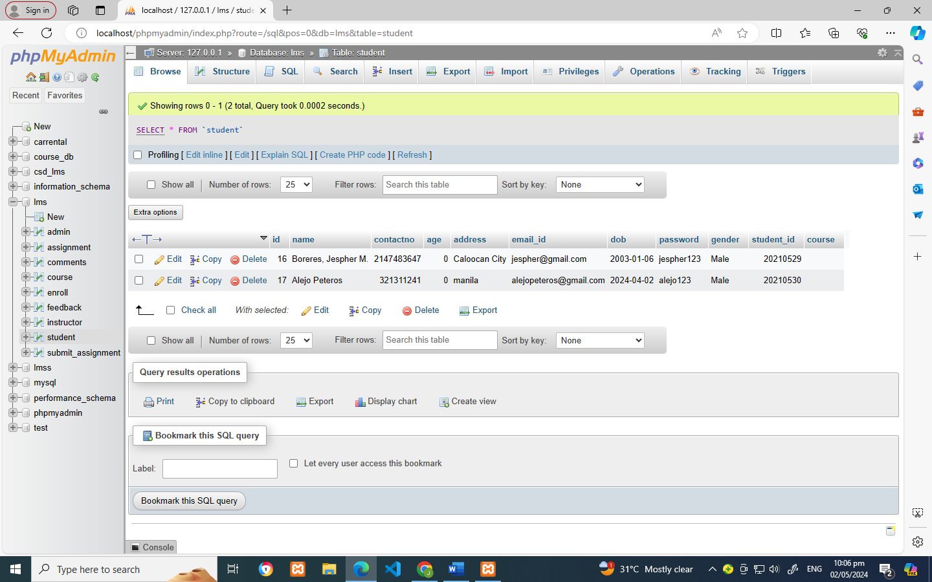

Instructor Table

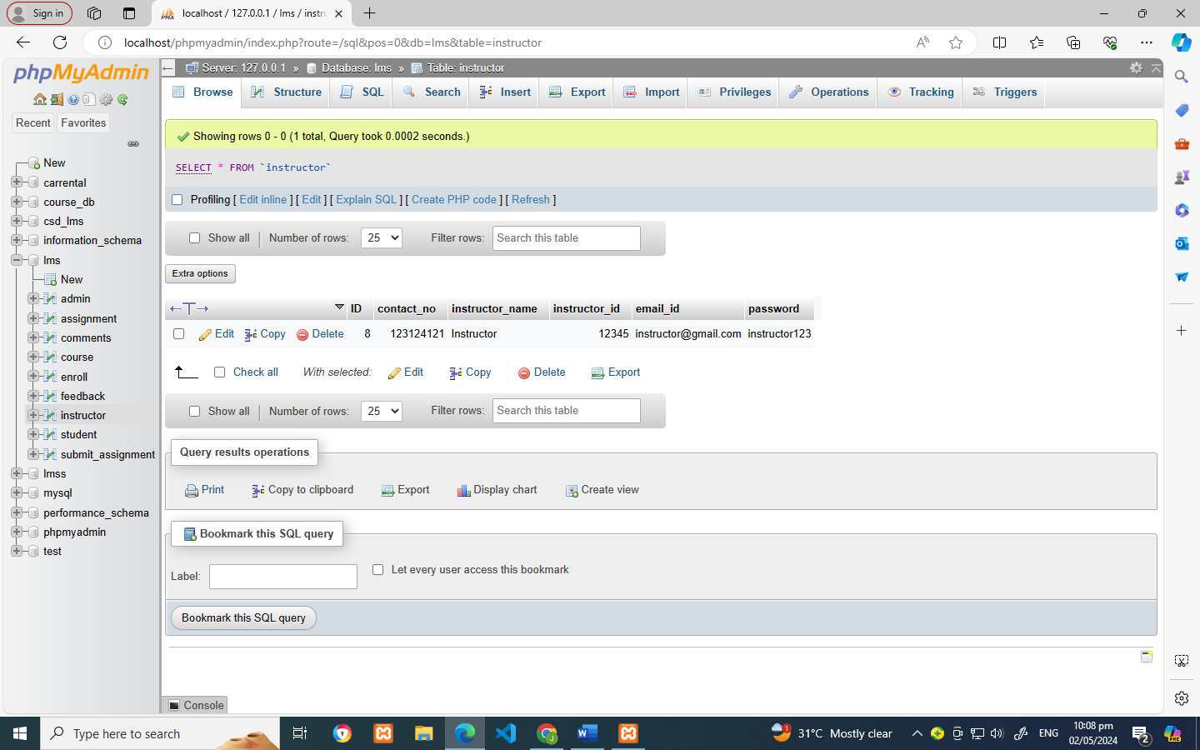

Enroll Subject table

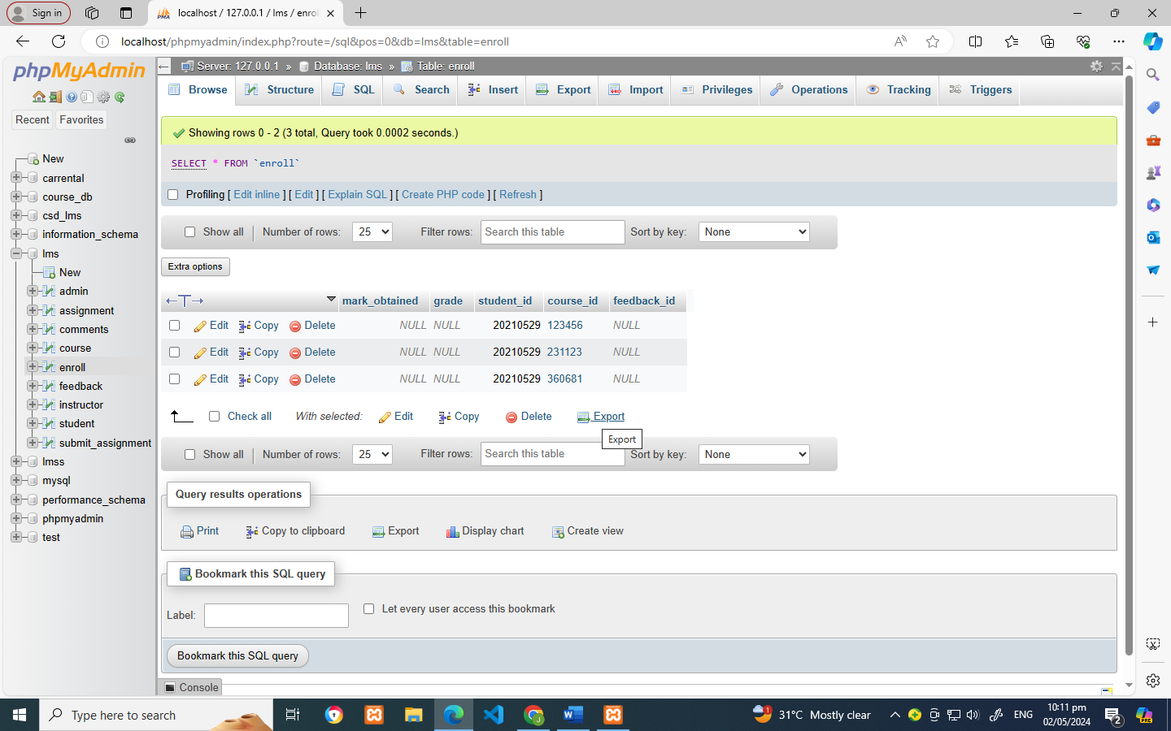

Subject Table

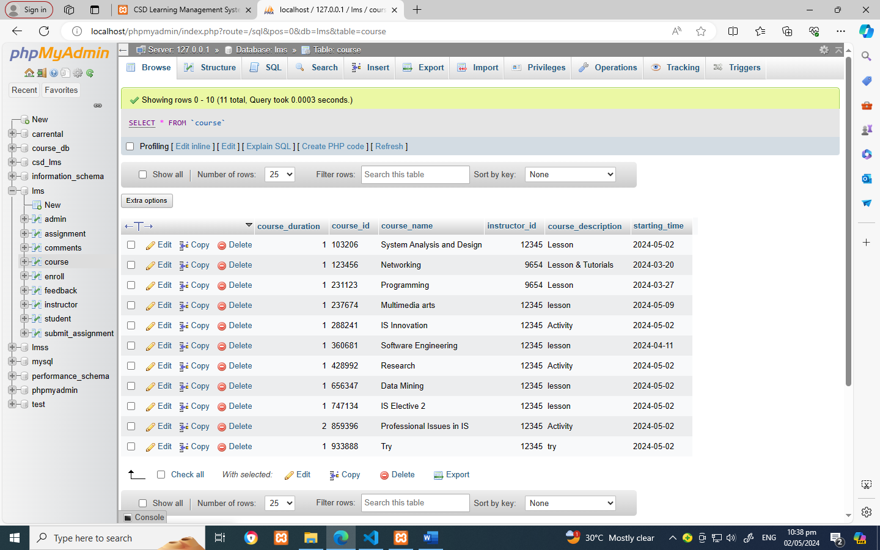

Submit assignment Table

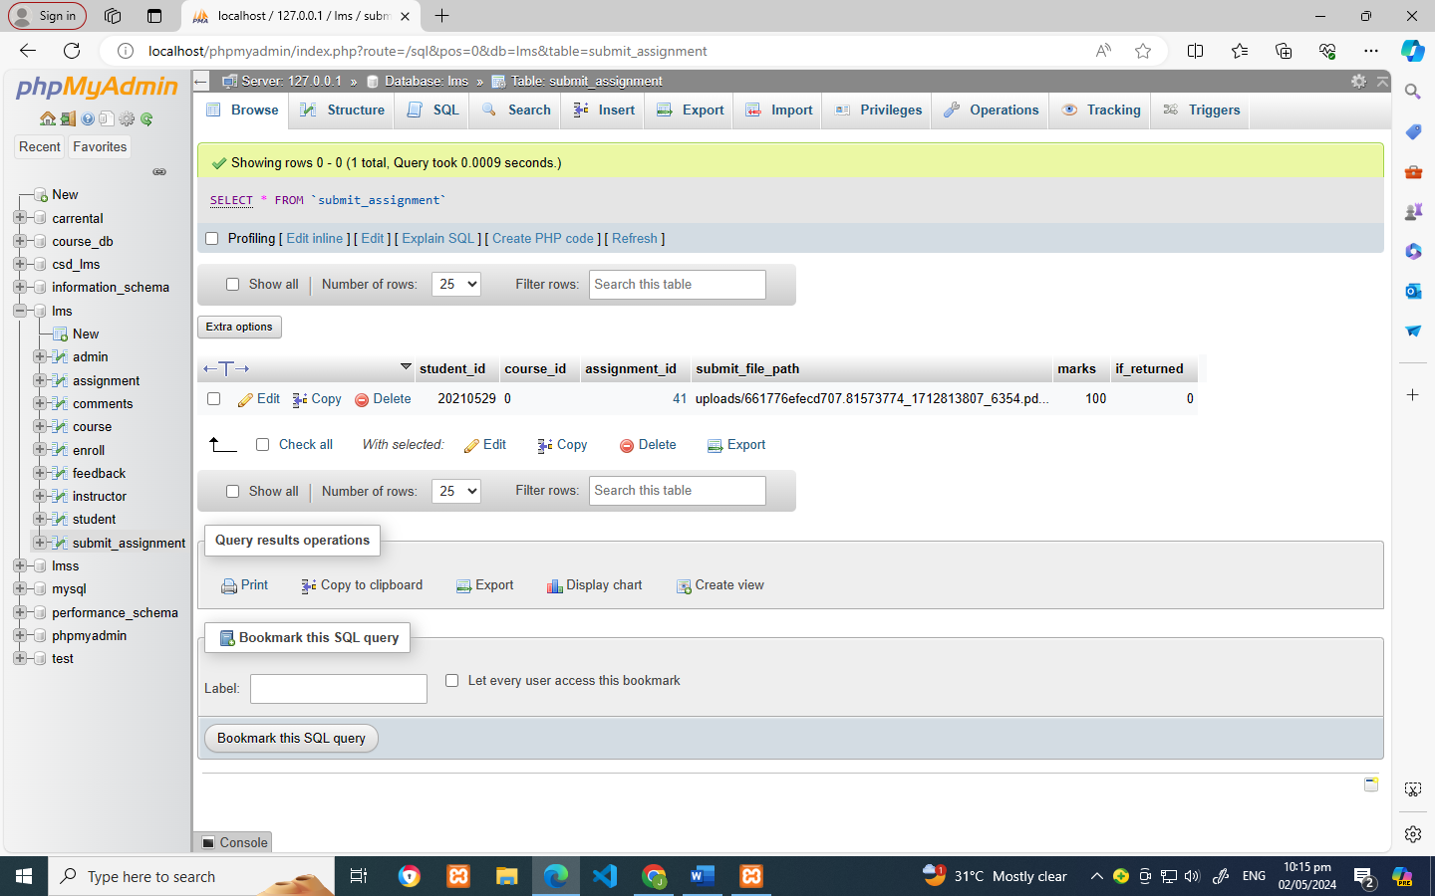

Assignment Table

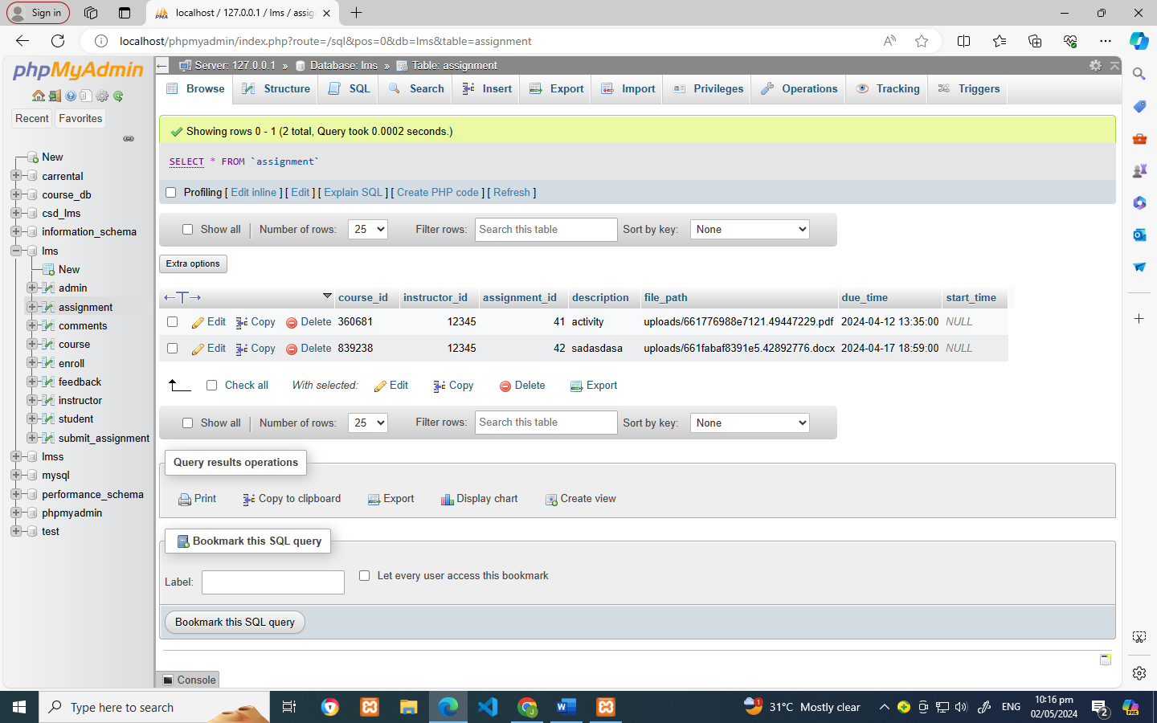

Comments Table

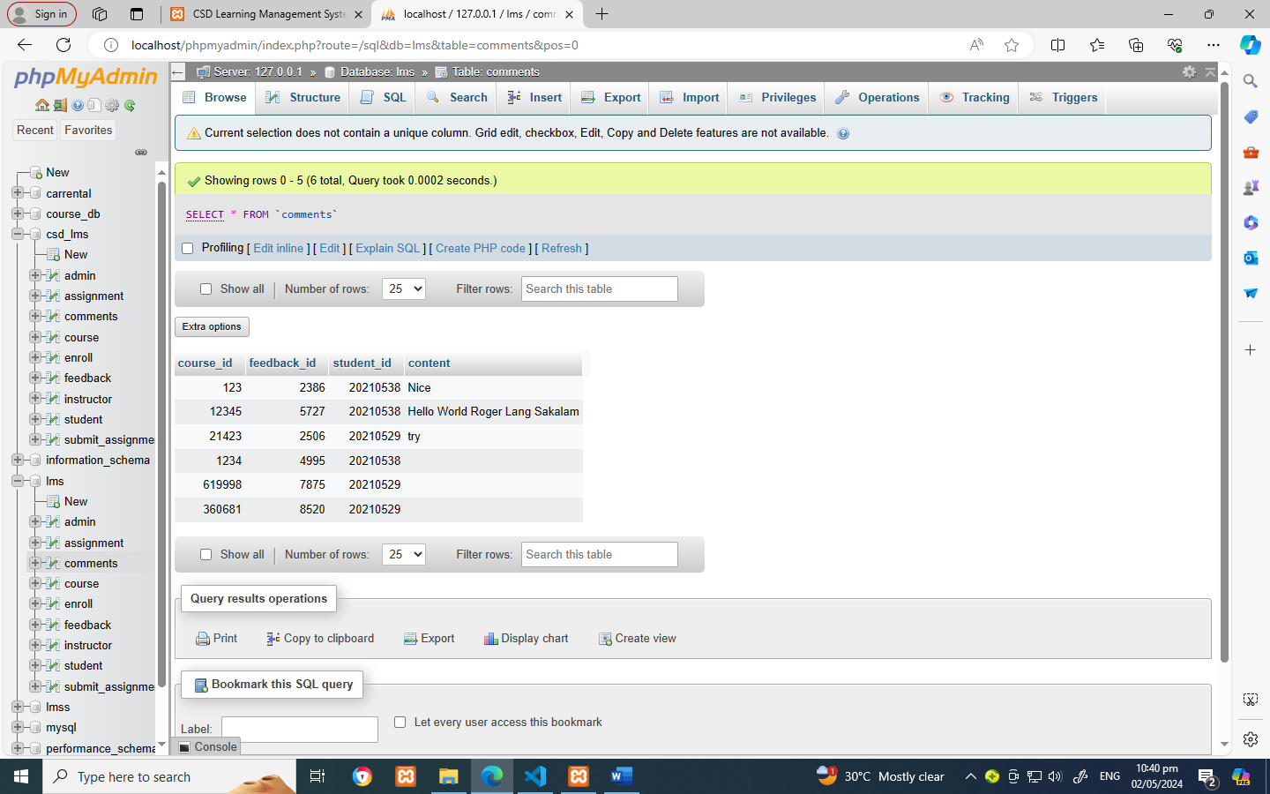

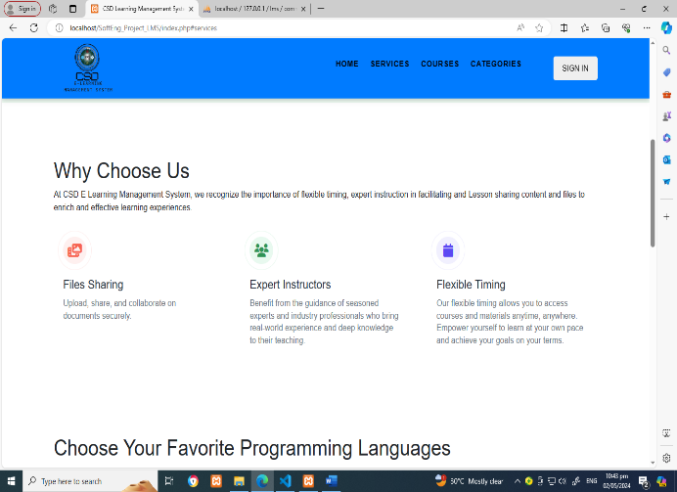**5.4 Screen Layout/ Specifications**

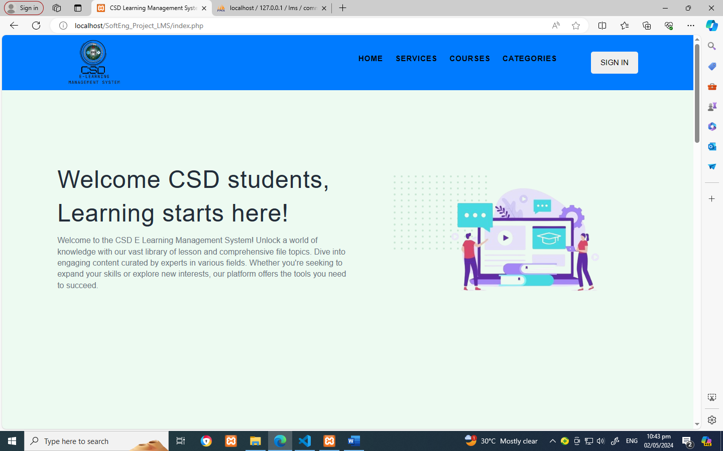

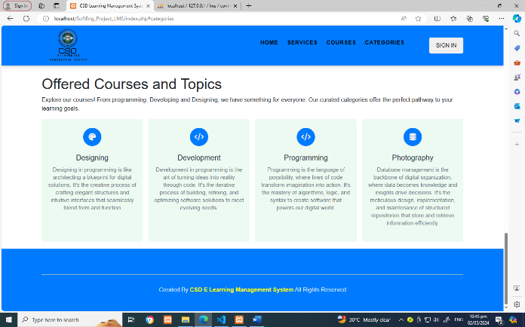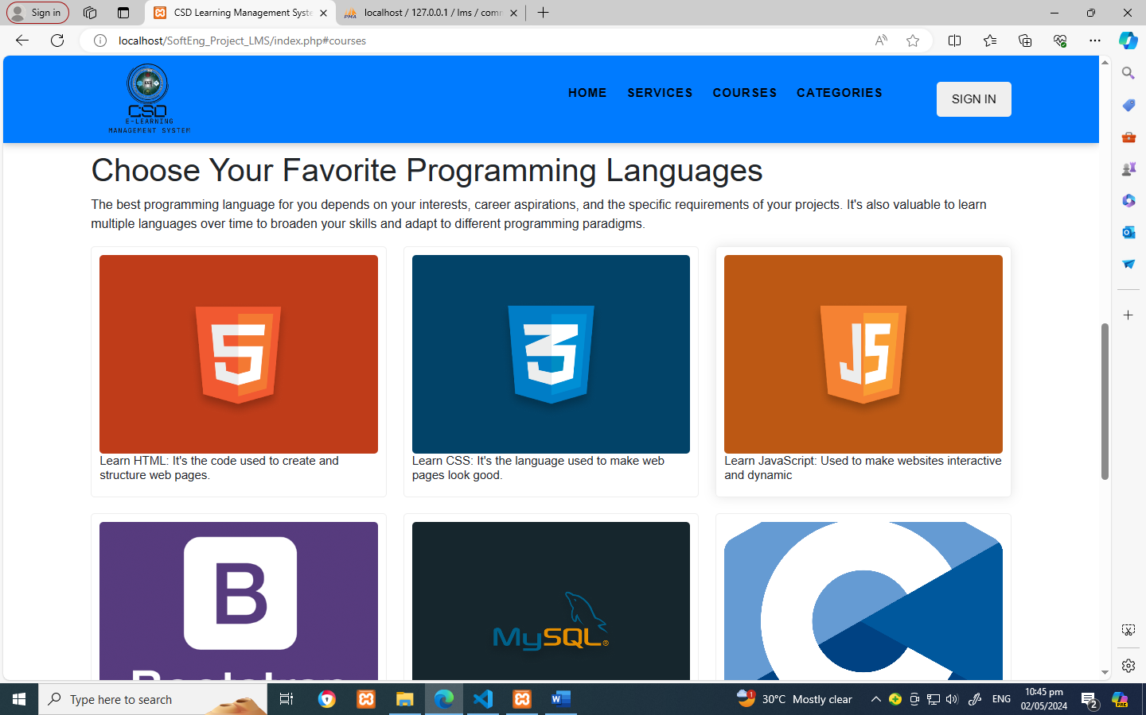

**5.5 Report/ Form Specifications**

**Login and Registration Form**

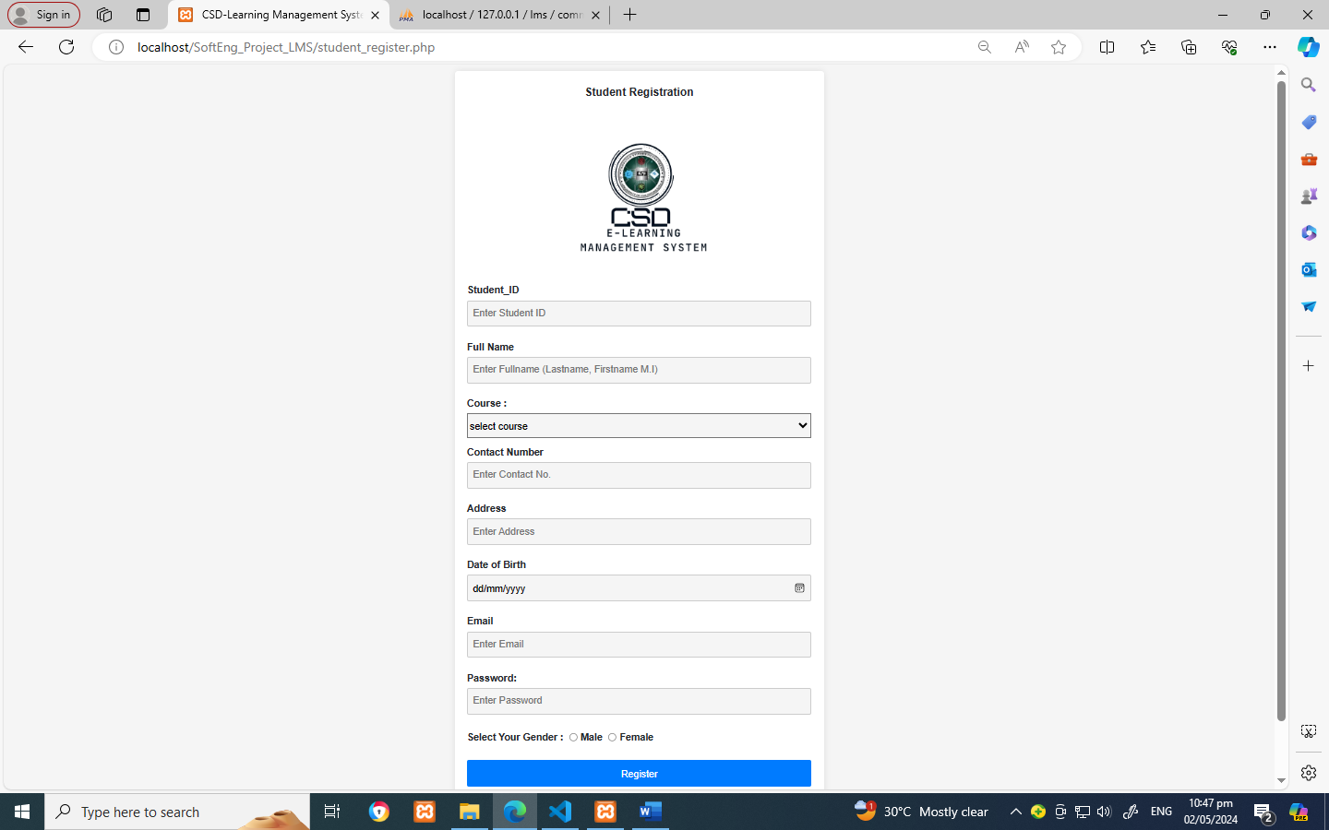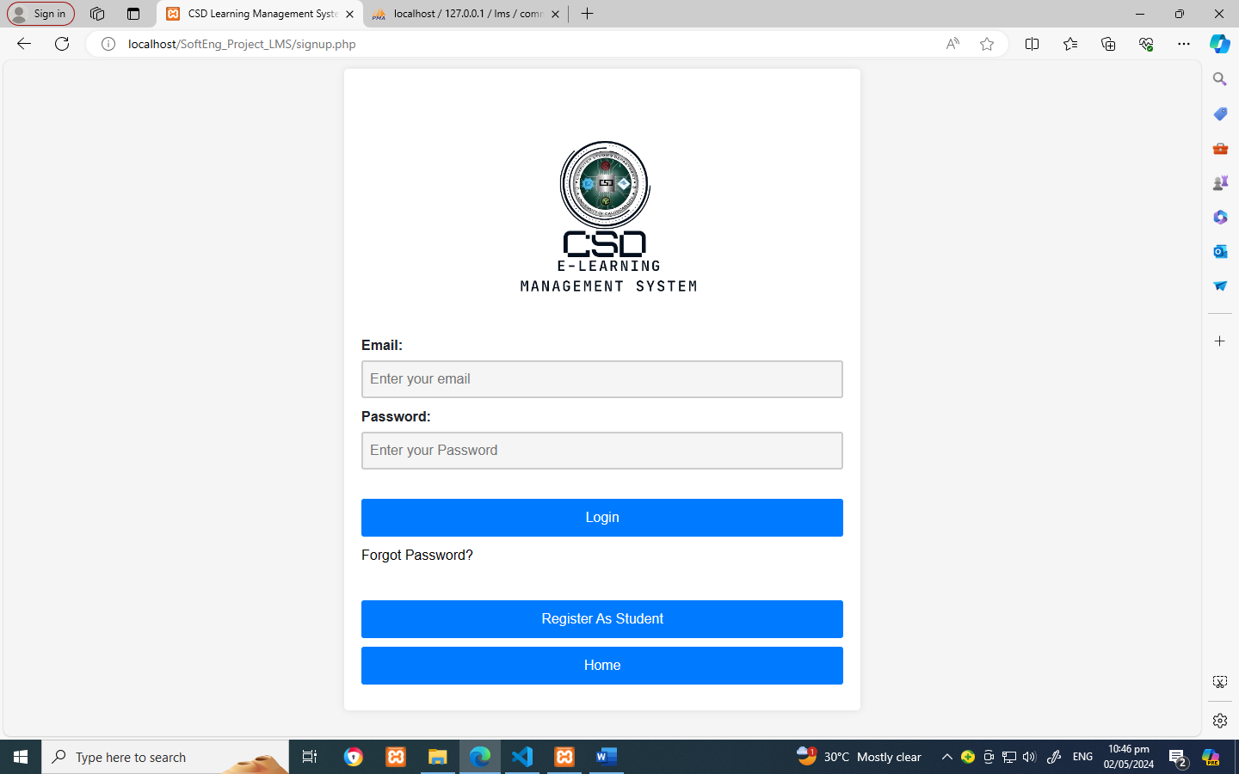

**Student Dashboard**

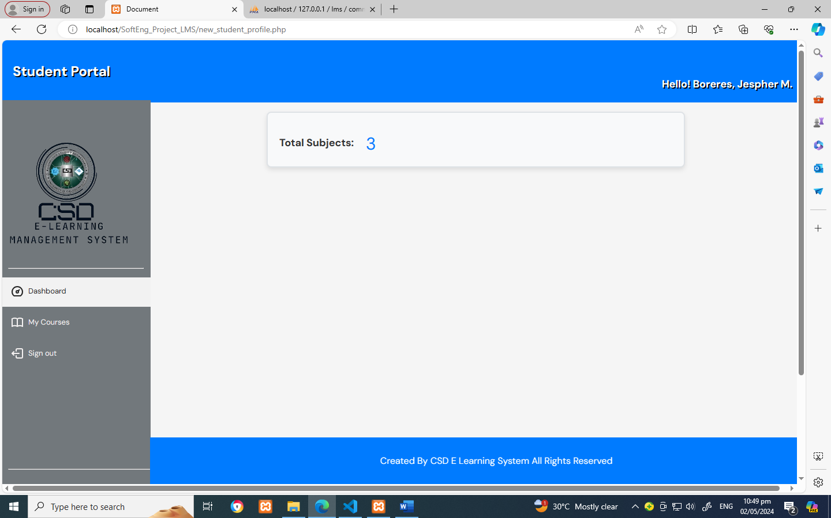

**Student Subjects Page**

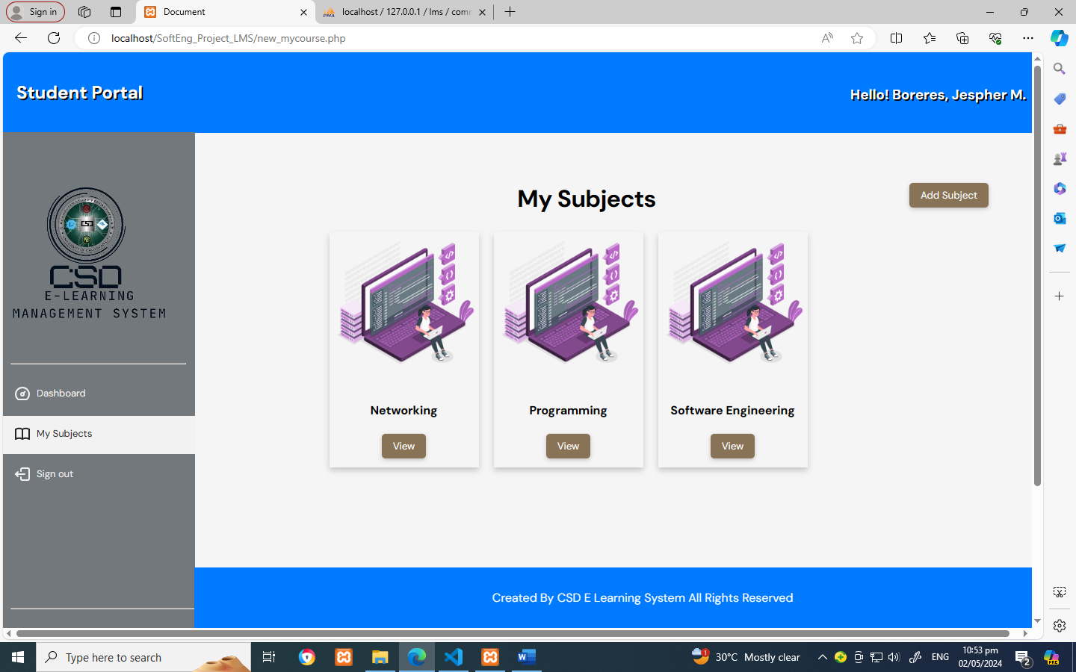

**Add Subject Page**

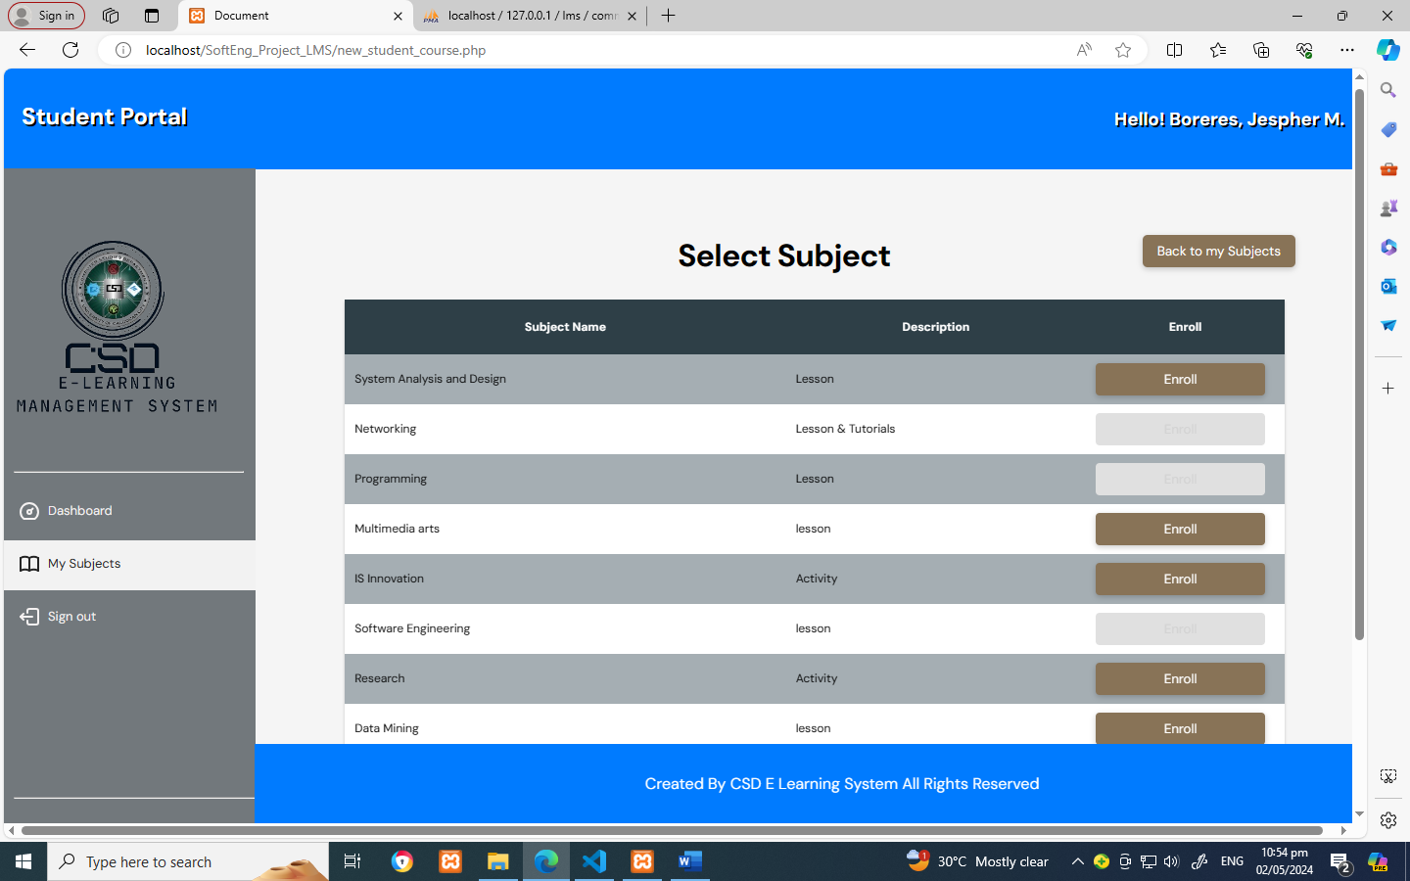

**View Subject**

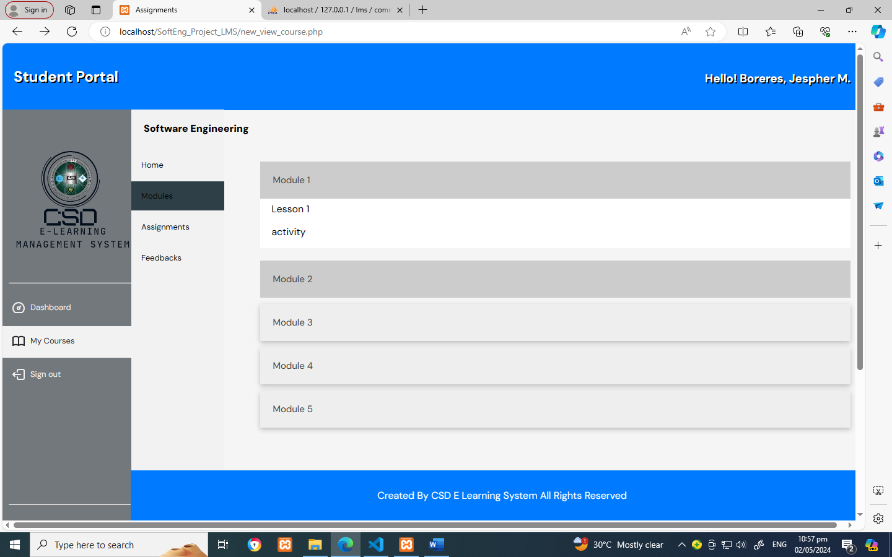

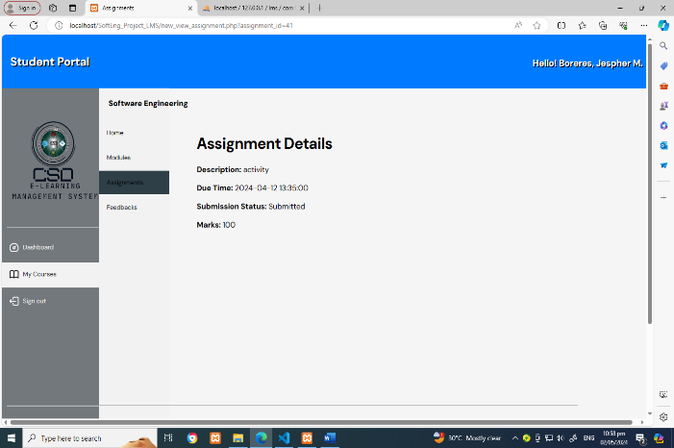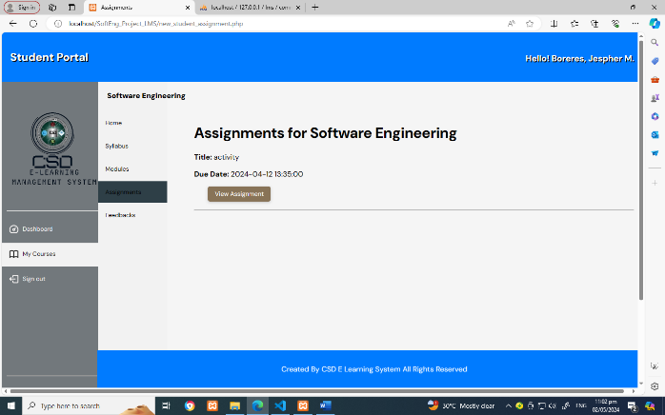**Assignment/Activity Details**

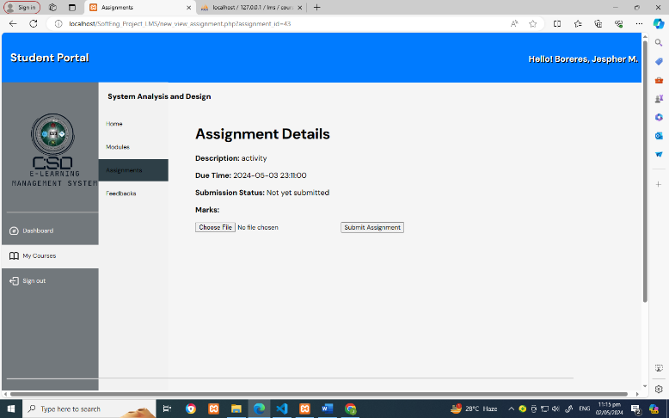

**Feedback Page**

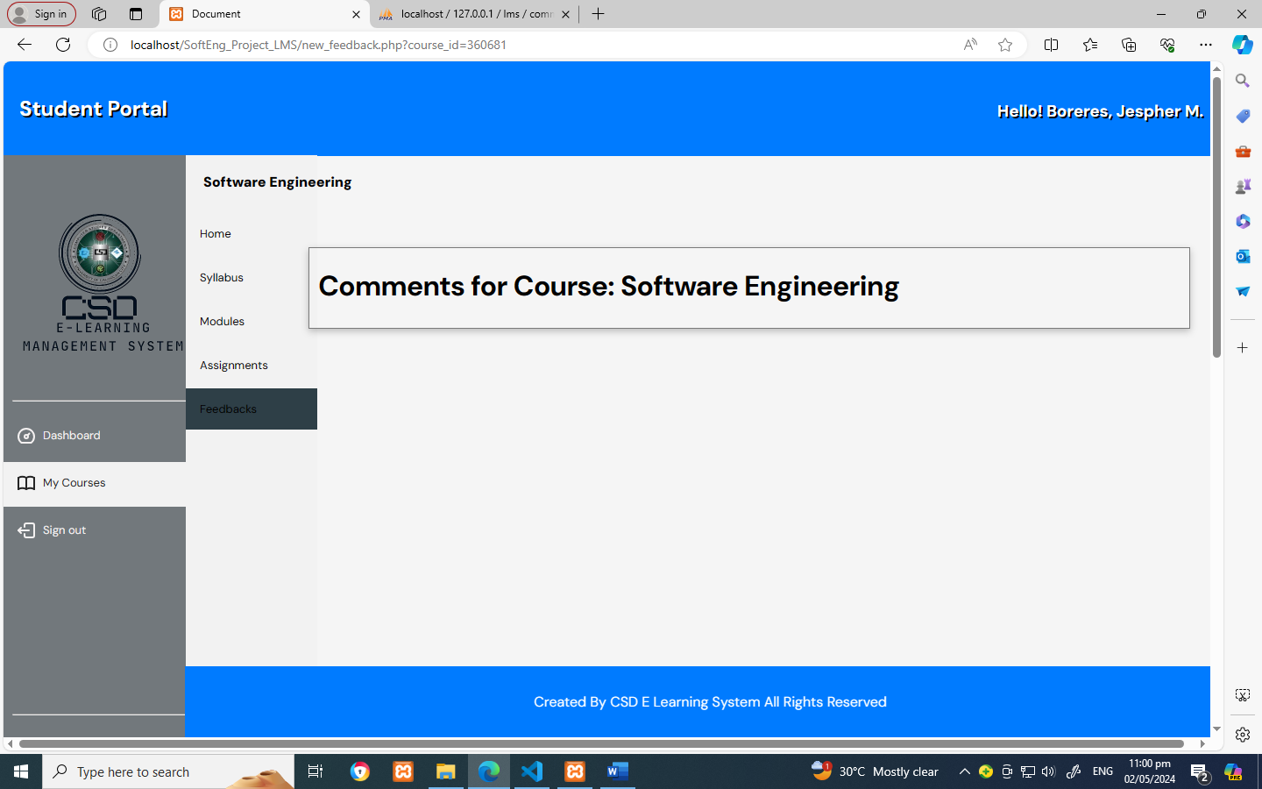

**Instructor Page**

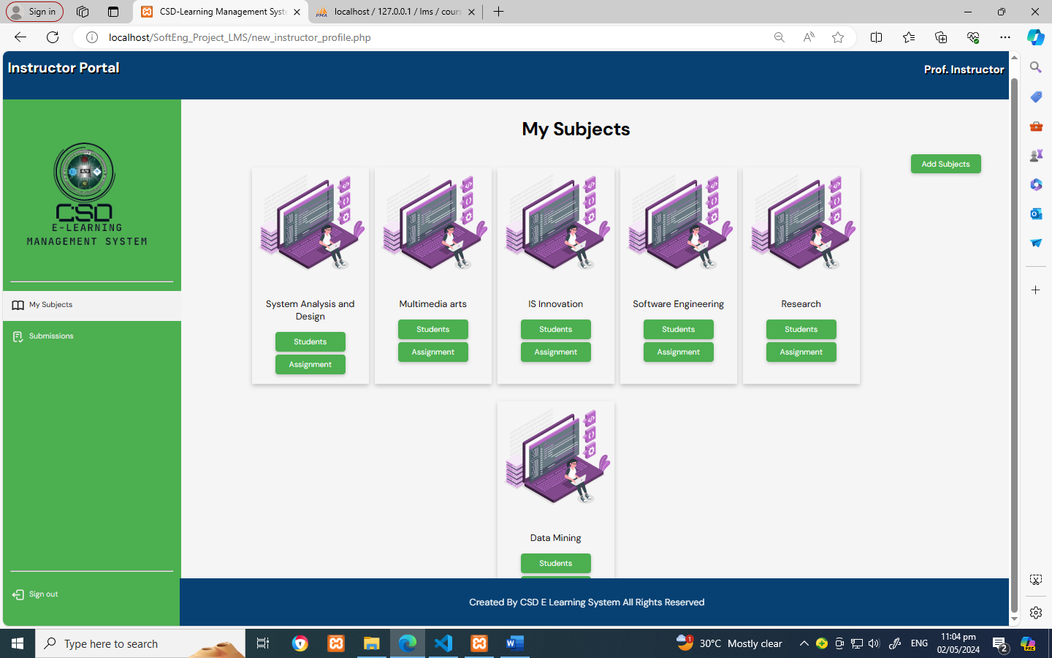

**Create Subjects**

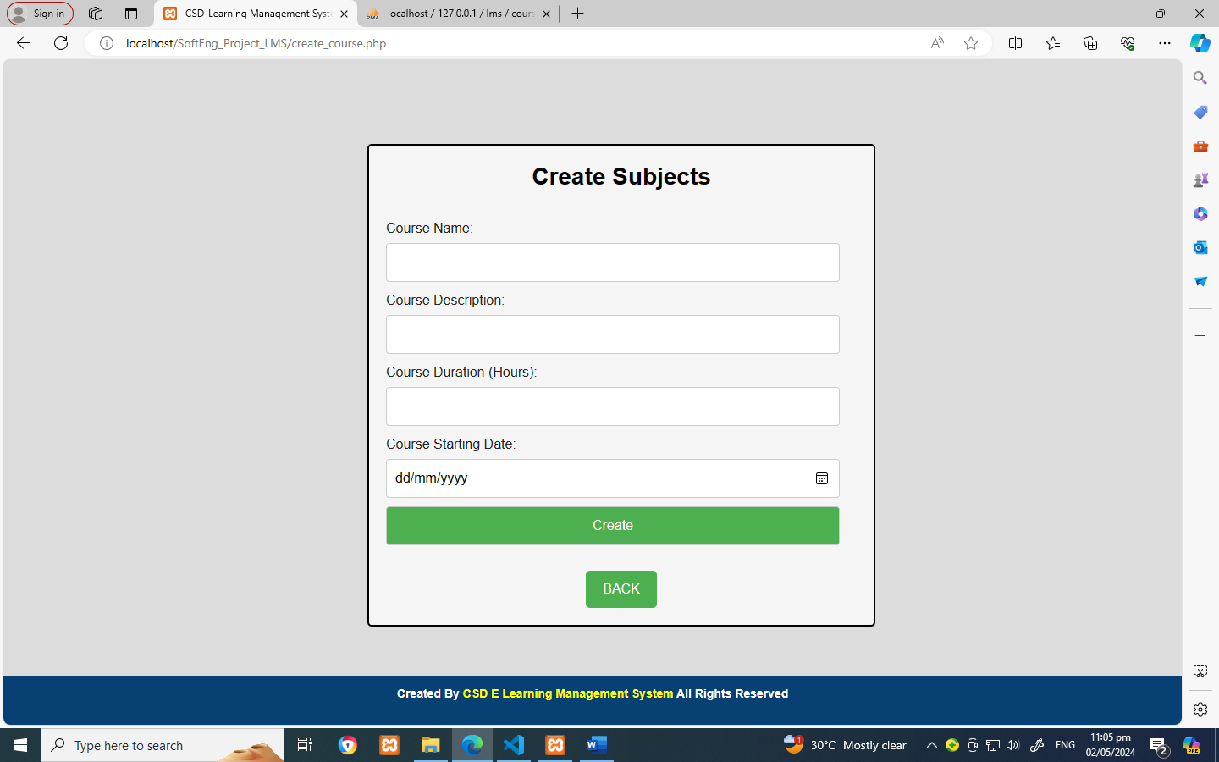

**View students enrolled**

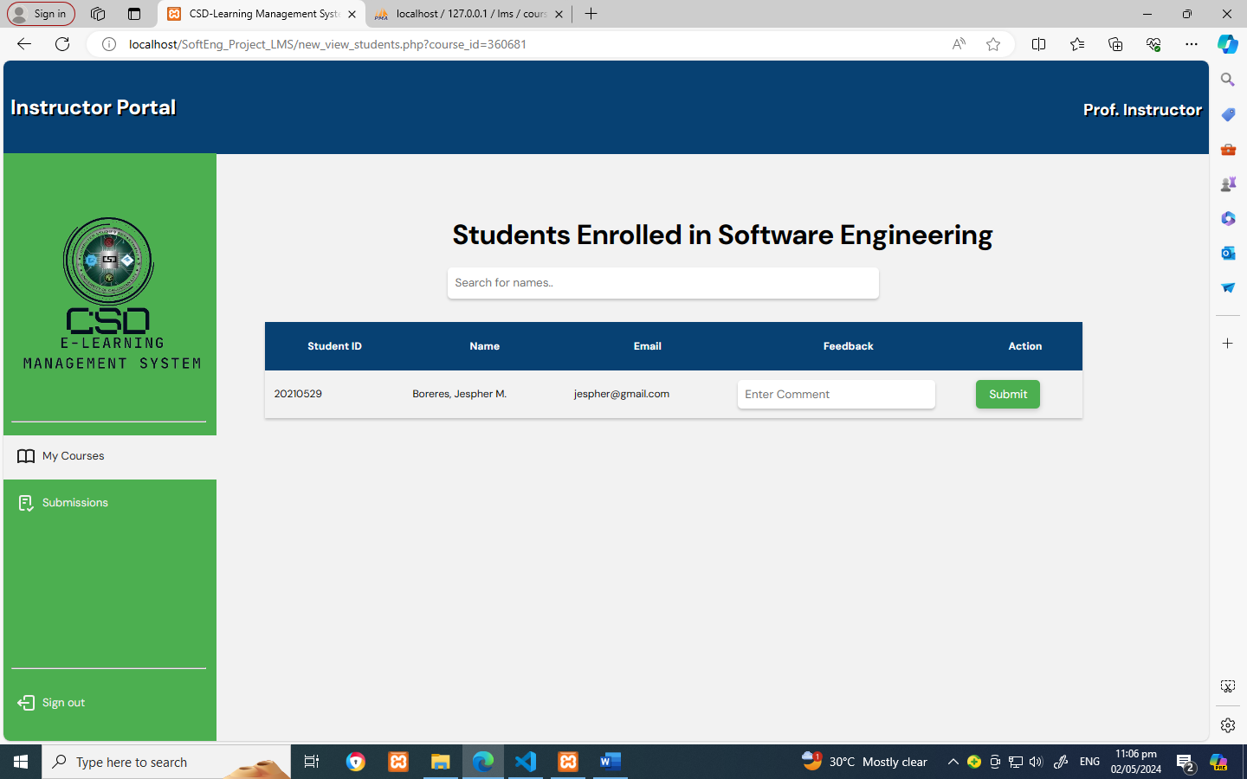

**Create assignment**

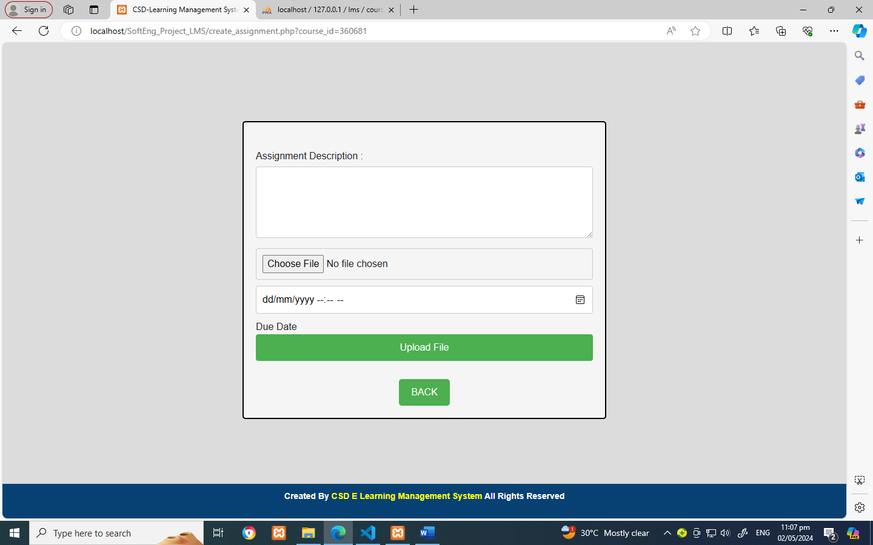

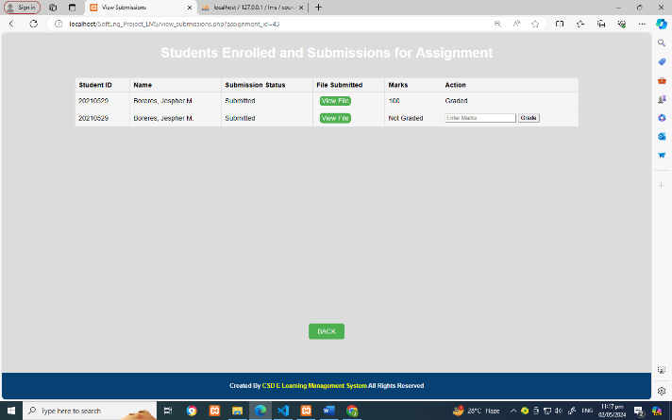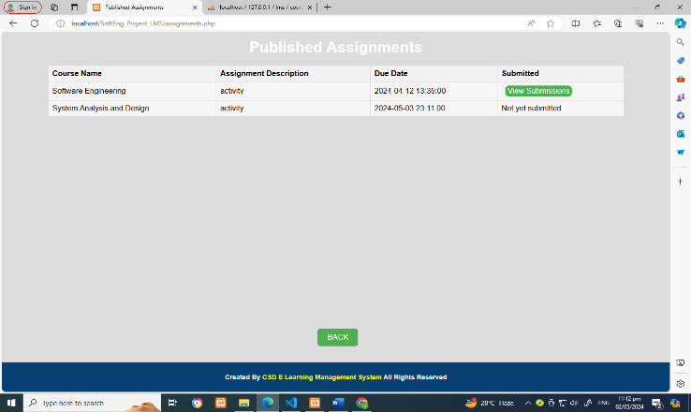**View Assignment / submission page**

**Admin side**

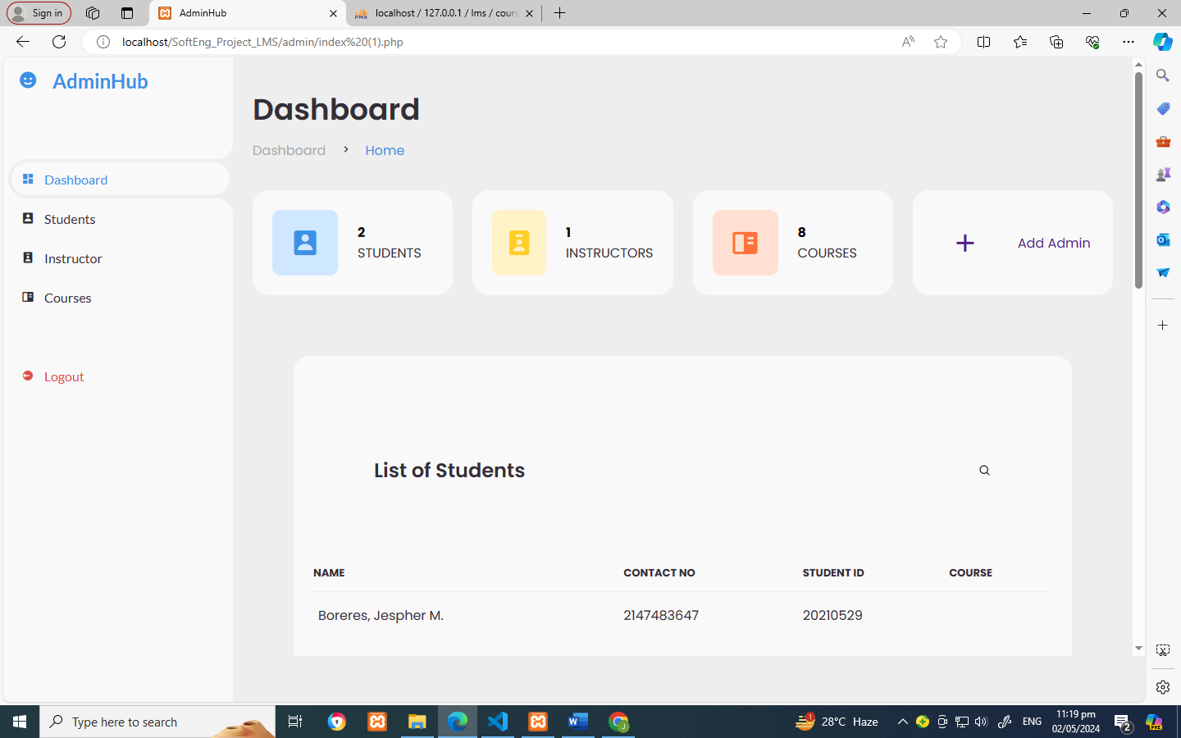

**Student List**

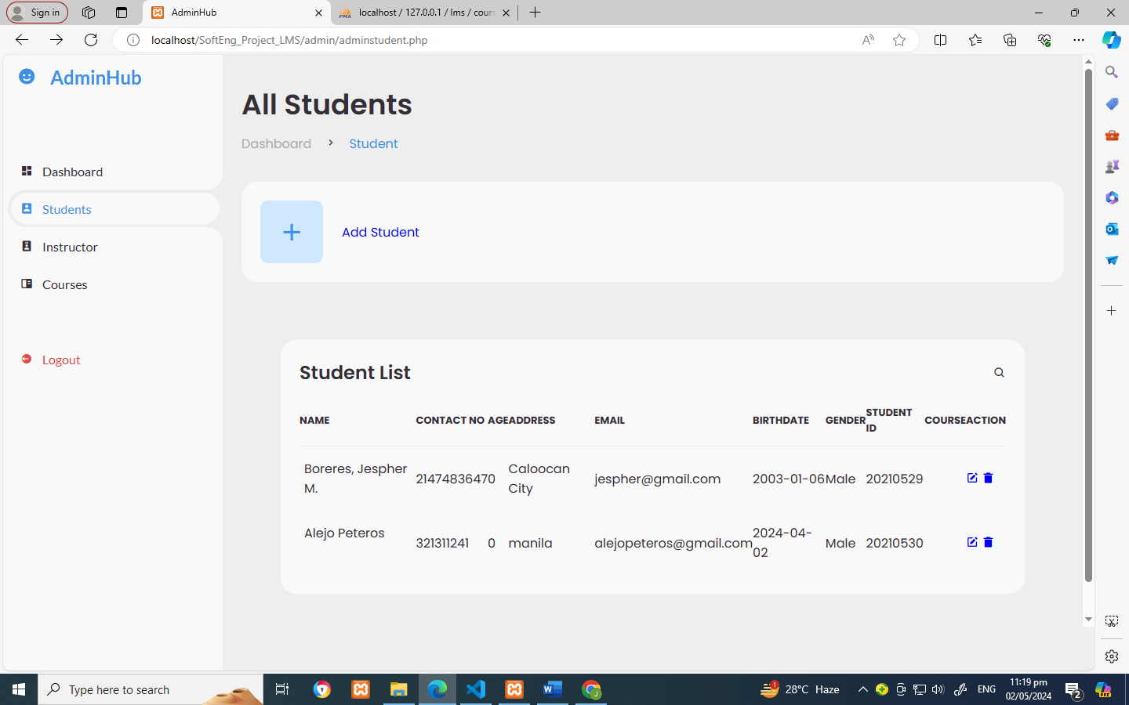

**Add Students**

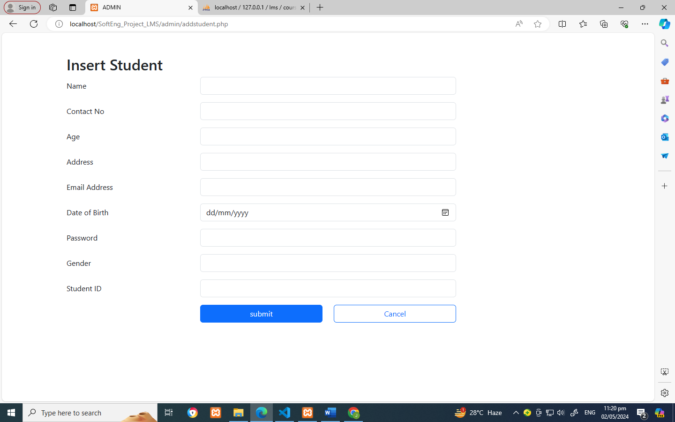

**Instructor List**

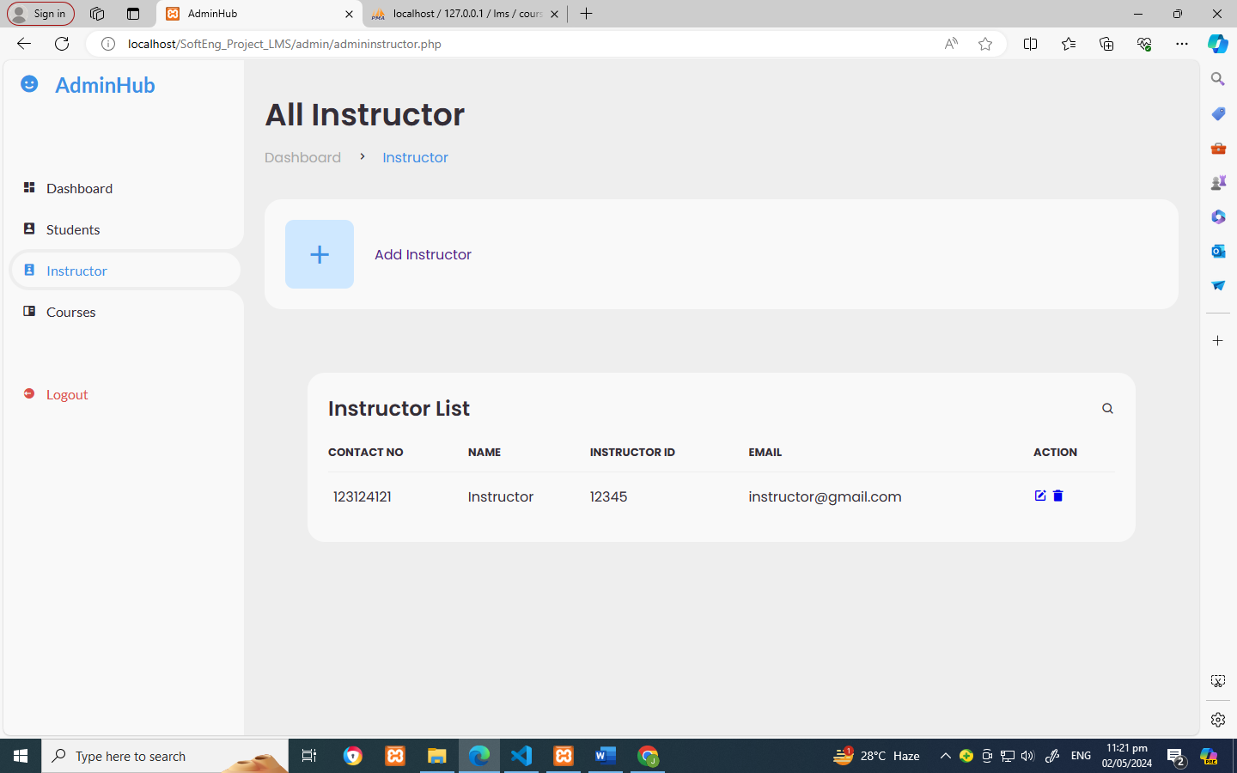

**Add Instructor**

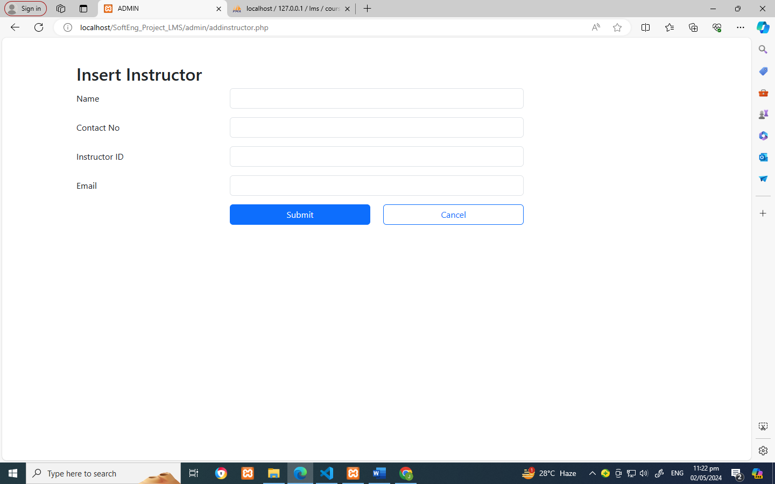

**Subject List & Add Subject**

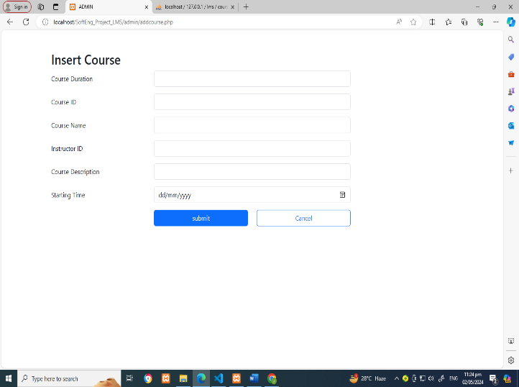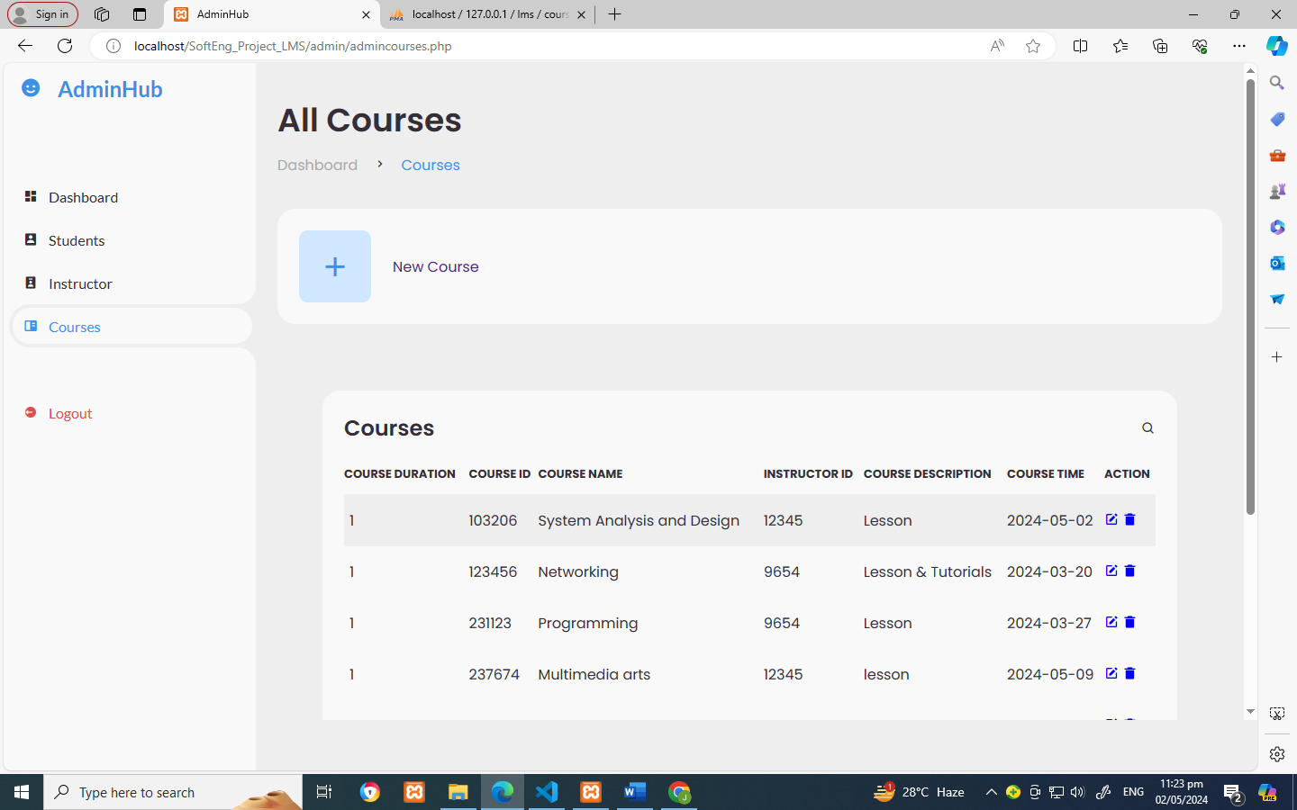

**5.6 Program/ Modules Specifications**

Grade

View

Published Assignments

**Create Assignment**

**Create Subject**

**Student Enrolled**

**Submission**

**Instructor Subjects**

**Instructor Dashboard**

View Details

Submit

Assignments

Feedback

Modules

Home

View

Subject

Add Subject

Total Subjects

**Student Subjects**

**Students Dashboard**

**Register**

**Login**

**Signup**

**Main page**